**NEIGHBORHOOD AND WORKPLACE**

**ELECTRIC VEHICLE CHARGING DEPLOYMENT**

**Title page- student + professor names**

**Acknowledgements**

**LCY program**

In a partnership between the City of Tacoma and the University of Washington for Livable City Year 2018, students were asked to work on various projects. The study in this report was conducted by students in a class on Transportation Energy and Sustainability and aims at assessing and suggesting strategies to improve the Electric Vehicle charging infrastructure in the City of Tacoma for residents. The following report will assess current characteristics of EV users, aggregate best practices, outline an action plan for encouraging the installations of chargers, and estimate the expected impact of these actions. One of the concrete goals of the City of Tacoma within the Livable City 2018 project scope was to strengthen the charging infrastructure in the city for both neighborhood and workplace charging. Tacoma asked for inputs for a strategy that can deploy resources accordingly to achieve the most effective and equitable results.[1]

**Contents**

**Executive summary**

**Introduction**

**Methods & approach**

1. **Private EV charging**

**Tacoma EV status**

**Multi-unit dwelling in Tacoma**

**Considerations**

**Challenges**

**Charging station options**

**Current policy reviews**

**Owner-renter structure**

**EV charger readiness for MUD in Tacoma**

**Cost-benefit analysis**

**Cost estimation**

**Scenarios in terms of owner-renter structure**

**Supporting options**

**Policy analysis**

**Policy framework**

**Equity and efficiency oriented policies**

**Peak demand strategies**

**Smart charger**

1. **Public EV charging**

**Conclusion**

**Appendix**

**References**

**Executive summary**

**Introduction**

Charging infrastructure has a significant effect on consumer adoption of electric vehicles (Evs). It is generally accepted that the relative attractiveness of EVs and other alternative fuel vehicles depends on several factors. These include up-front cost, operating costs including fuel (electricity) and maintenance, range, refueling/recharging time, the availability of refueling infrastructure, environmental impacts, and government incentives. In the case of EVs, many of these factors are determined by the charging infrastructure: the number, type, locations, and pricing of charging stations. It is generally accepted that to make EVs more attractive to consumers, charging opportunities should be ubiquitous, fast, and inexpensive.

**Methods and approach**

Divided into 2 sessions: 1) private EV charging stations (single family households and MUD households) and 2) public EV charging stations (work place and public).

The following report will introduce the topic through providing some rationale why the investment into an electric vehicle supply equipment (EVSE) infrastructure is valuable. Following this, methods and considerations to define possible policies will be presented. First, best practices will be reviewed, followed by an assessment of the technical challenges of EVSE installation and an estimation on the cost of installing EVSE based on different local circumstances. After accounting for additional considerations, a quick cost benefit analysis will be presented that assesses how the benefits of an installation of chargers are distributed based on different cases. Based on this, an incentive assessment is presented that elaborates on how different rebates and other incentive approaches can effectively increase the attractiveness of investing into chargers. The results of these methods are then used to create a framework in which different policy options can be optimized based on the higher objectives of the City of Tacoma. Within this framework, the effects of optimizing either for achieving a high efficiency or a high equity will be illustrated and the corresponding policies will be presented including an estimation of the cost of their implementation given the EV target of the City of Tacoma for 2020. Lastly, an alternative approach will be presented that focuses more on quick wins and can be a valuable addition to the policies presented. The report will be closed with conclusions and final recommendations that give an outlook on the applicability and further extension of the policies.

Limits

The analysis performed within this report is based on many assumptions that had to be made since detailed data on the situation in Tacoma was not available for many cases at the time of the analysis. Thus, to get more accurate results, it is recommended to create a detailed Tacoma EV readiness data inventory e.g. based on surveys on the EV readiness status distribution, the income distribution, the ownership structure and the interest of residents to actually invest into EVs.

**Private EV charging stations**

Tacoma EV status

In Tacoma, over 75% of the lands are zoned residential. Most citizens live in the single family dwellings. Understanding characteristics of dwellers and their charging behavior is necessary and vital for the research. From an Idaho National Laboratories study, 85% of all charge events occur at home and 50% of citizens charge exclusively at home.

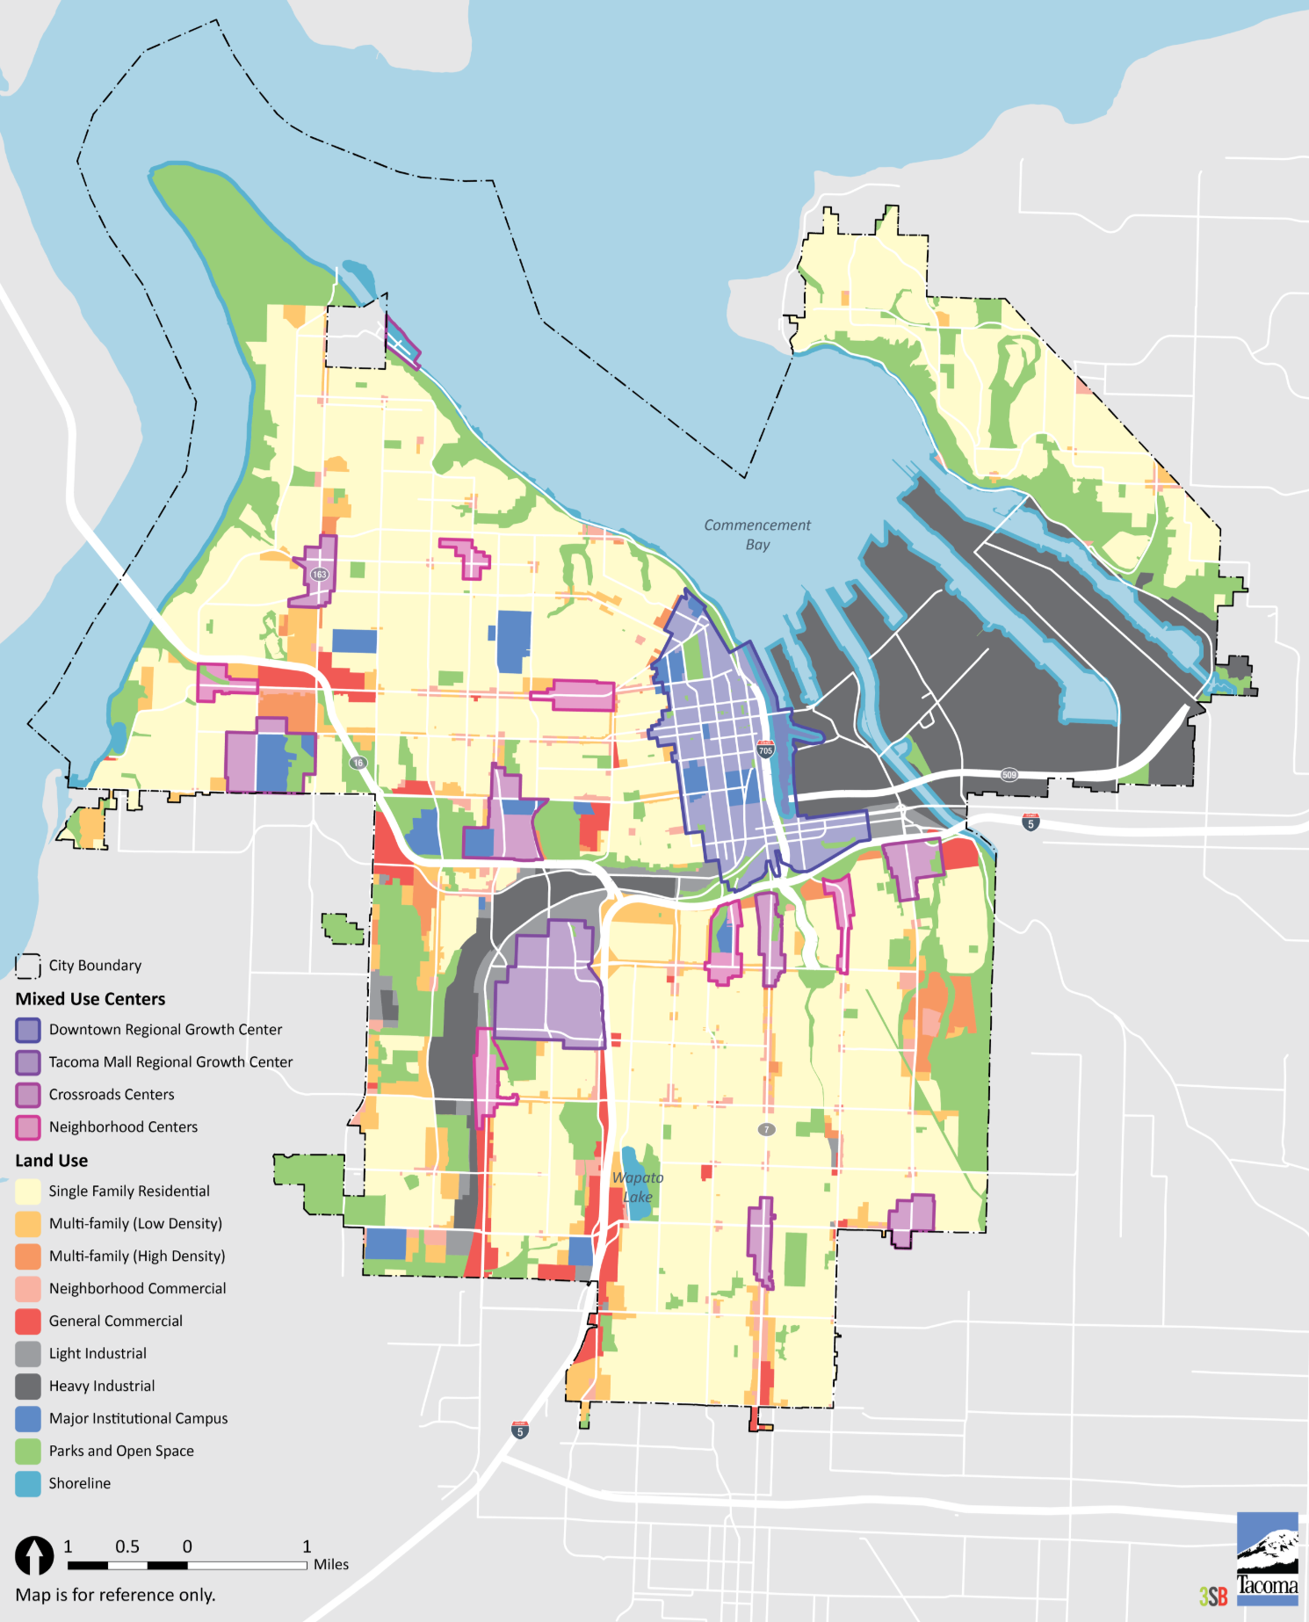

Figure 1 Map of the Zoning Districts in Tacoma

The number of plug-in hybrid electric vehicles (PHEVs) and battery electric vehicles (BEVs) registered in Washington State increased by 70% between mid-2014 and the end of 2015. Currently, 523 EVs are registered in Tacoma. If Tacoma is to achieve the vision of 2000 plug-in vehicles by 2020, it will need to further increase EV adoption. Therefore, it is important to know which factors influence the adoption of EVs among residents of Tacoma. In this section, the expected rates of EV adoption based on residents’ demographics in each ZIP code will be estimated.

First, the number of EVs registered by each zip code which was provided by the City of Tacoma is used to set up a model based on residents’ demographics from Census data. To examine the current status of EV adoption in Tacoma, expected adoption rate of EVs in each zip code is estimated using a zero-inflated negative binomial model and compared with the current adoption rate of EVs. The difference between expected and actual number of EVs in each zip code is then visualized. Figure below shows areas, shaded in green, where actual EV adoption exceeds the predicted adoption. Likewise, grey areas are those where actual EV adoption fall short of the levels expected based on sociodemographic characteristics.

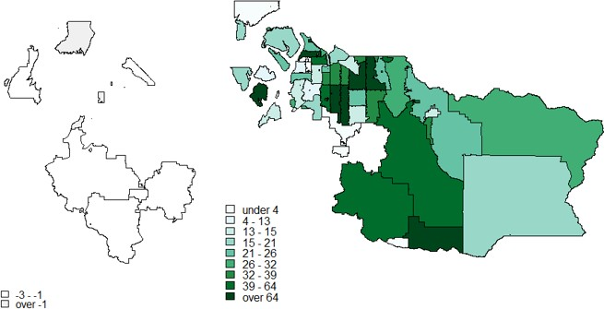

Figure 2 EV adoption per the predicted for each zip code

Most of the ZIP codes in Tacoma, have more EVs than expected. According to the sociodemographic characteristics of each ZIP code which were significant in the final model, the EV adoption rate increases as the number of well-educated residents increase in each zip code. The population density of a zip code has a negative effect on the rate of EV adoption. The EV adoption rate in a zip code rises as the percent of high income households increases in that zip code. Employment per household positively affects the rate of EV adoption in each zip code. The percent of children (under 18 years old) in each zip code has a negative effect on the EV adoption rate. In addition, a larger fraction of high-income households makes increases the numbers of EVs in adopting areas.

Multi-unit dwellings (MUD) in Tacoma

In addition to single family households which is the majority of residents in Tacoma, it is necessary to consider multi-unit dwellings (MUD) in Tacoma from the equity perspective. The rationales to consider MUD are as follows.

(1) Electric Vehicle Supply Equipment (EVSE) in MUDs was not emphasized.

As the American Community Survey (ACS) reports, 30662 housing units in Tacoma are located in MUDs, taking up 35 percent of the total housing units[2]. Furthermore, according to the Tacoma residential building permit records, the number of permitted MUD units are 5 times higher than permitted single family units[3]. However, the current infrastructure in electric vehicle supply equipment (EVSE) in MUDs is far from meeting the needs of these residents. Among all the Electric Vehicle (EV) charging stations in Tacoma that are listed on the plugshare website[4], only one station is installed at an MUD (which is Copperline Apartments). Since the availability of home charging will greatly influence people’s willingness to purchase EVs, more effort and investment needs to be put on incentivizing EVSE in MUDs.

(2) Demand of home charging is high, especially in MUDs.

Smart and Schey conducted a study on electric vehicle charging behavior[5] and observed that 82% of the charging events of the investigated sample happened at home. Moreover, as the 2017 Puget Sound Regional Council (PSRC) Household Travel Survey data shows[6], the sample from Tacoma shows a higher proportion of EV ownership in MUDs (13%) than across all surveyed households (11%). Even though these results are overestimated due to self-selection bias (the amount of EVs currently registered in Tacoma is less than 1% of the total number of registered vehicles), it still provides evidence that MUD residents have a significant demand for an EVSE infrastructure.

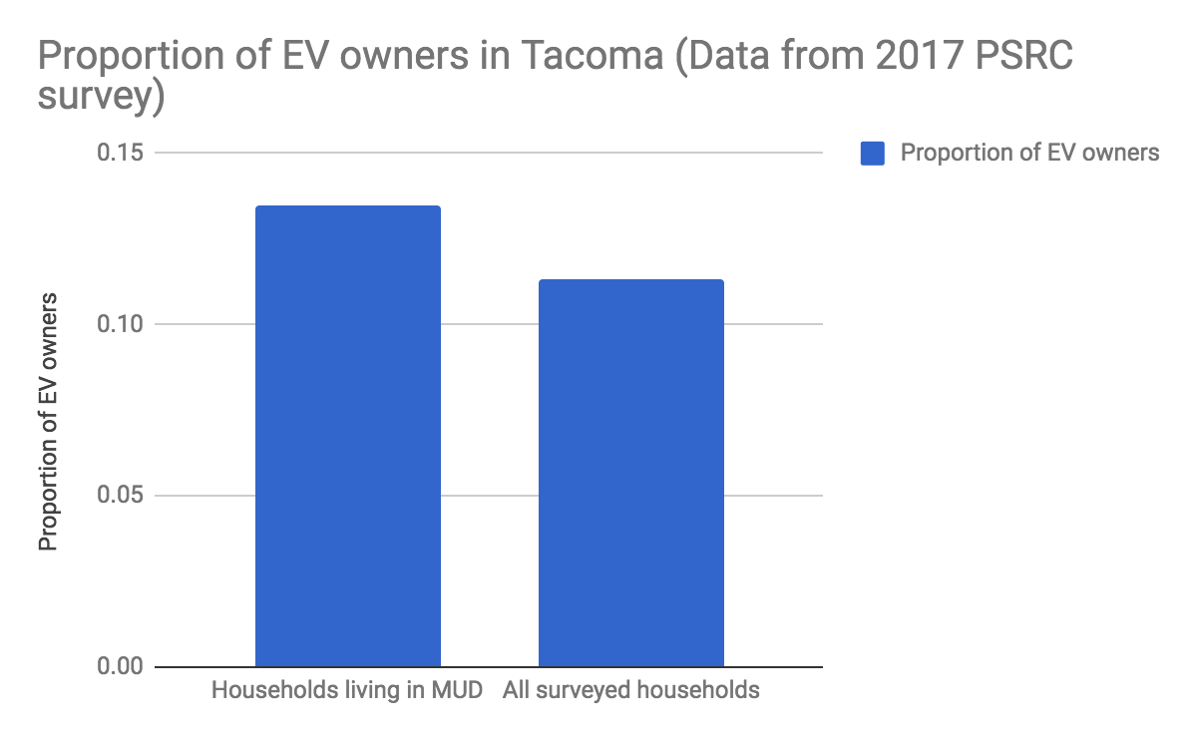

Figure 3 Proportion of EV owners in Tacoma (Data from 2017 PSRC survey)

MUD EV ownership in Tacoma (Data from 2017 PSRC survey)

|  |  |  |
| --- | --- | --- |
|  | MUD Households | All households |
| Households owning EV (including PHEV) | 7 | 19 |
| All surveyed households | 52 | 168 |
| Proportion of EV owners | 13% | 11% |

(3) MUDs have the potential to receive a more equitable and more economic EVSE structure.

In the scope of this study the social characteristics of different blocks in Tacoma were analyzed and as is shown in table below, blocks with MUDs are likely to have higher population density and a higher proportion of rental housing. Therefore, in order to achieve social equity in EVSE accessibility, the government should consider suitable charging solutions for MUDs in addition to public, workplace and single-family residence charging. Moreover, based on a performed cluster analysis, two clusters of MUD-intense blocks, as is shown in Figure below, are found to have different social characteristics. Compared to Cluster 1, Cluster 2 has a higher population density, lower average income, lower education level, higher building age and a higher proportion of rental housing. The government needs to develop different strategies to address EVSE installations for the two clusters.

Result of Logistic regression (MUD-intense blocks vs. the other blocks)

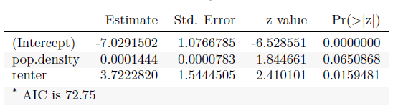

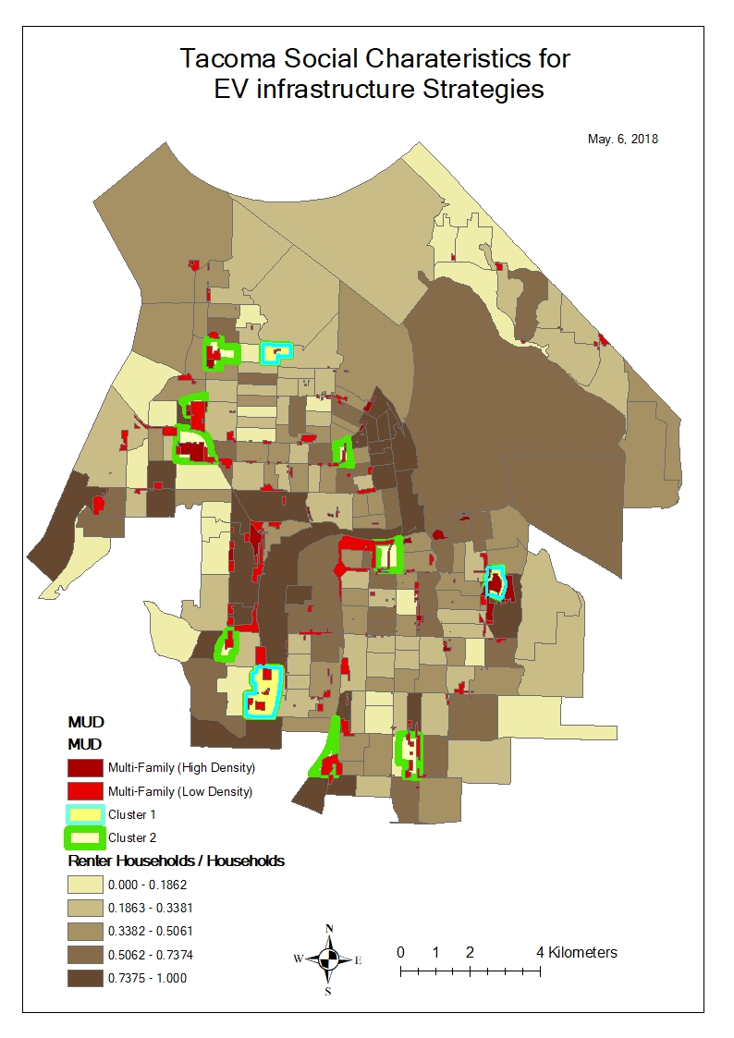

Figure 4 Cluster Analysis of MUDs Residents’ Social Characteristics

Compared to single family residences, MUD charging stations are likely to have a higher utilization rate due to a higher population density, thus making it a more economic option. The MUD residents’ trips that originate from the residence are distributed throughout the day, as is illustrated by Figure below, which suggests that charging events are likely to be distributed further throughout the day, which causes the usage rate of each charging station to be higher.

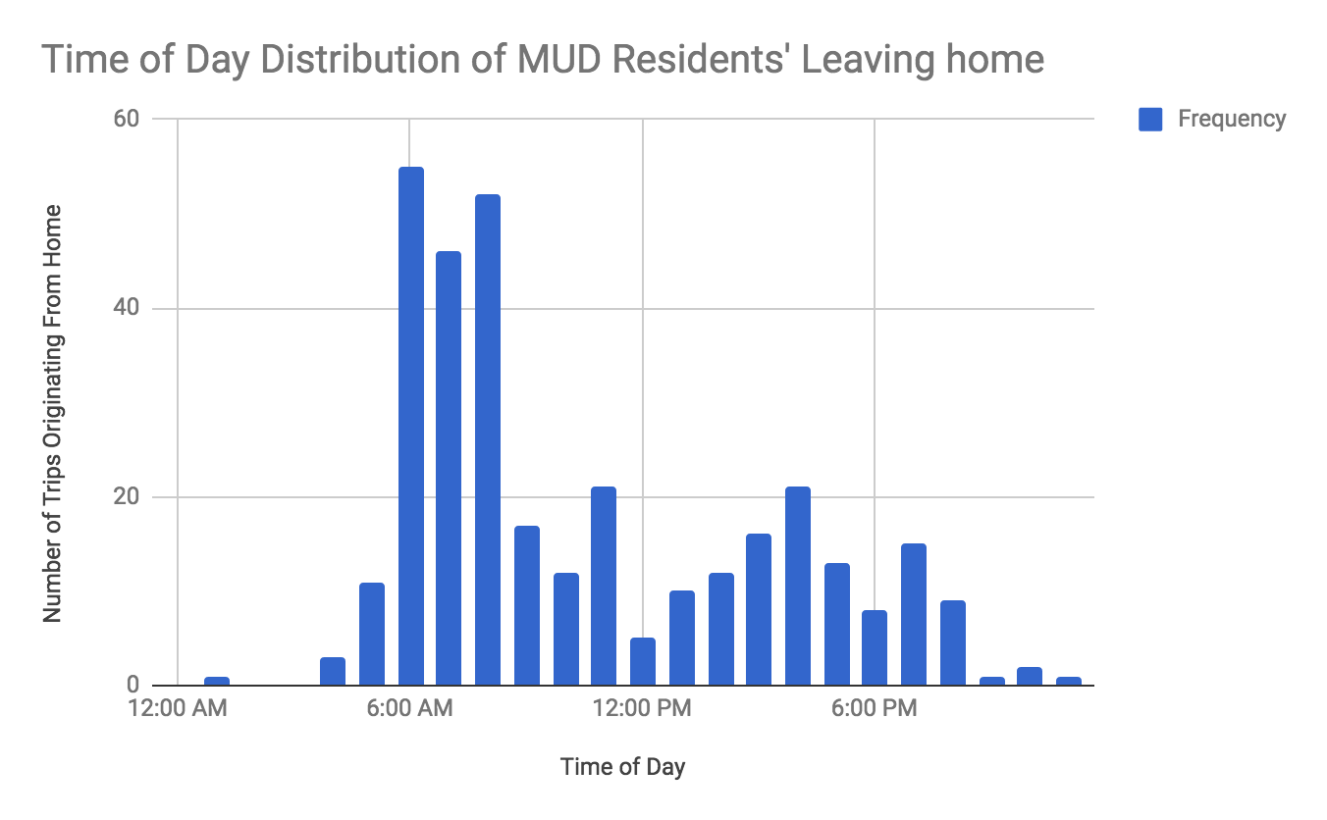

Figure 5 Time of Day Distribution of MUD residents’ Leaving Home (Data from 2017 PSRC survey)

(4) MUD in Tacoma has suitable parking situation for installing EVSE.

Lack of parking space is usually a barrier to install charging station in MUD. Thus, the MUD parking situation in Tacoma was analyzed through satellite pictures and GIS mapping. Areas with MUDs are widely dispersed across the city area and about 95% of MUDs exhibit sufficiently large surface level parking for residents, which is shown in Figure below. The only area that was found to have insufficient on-premises parking is the historic downtown. Overall, there are sufficient parking spaces in MUDs for installing EVSE and it is recommended that government project focuses on MUDs with surface level parking.

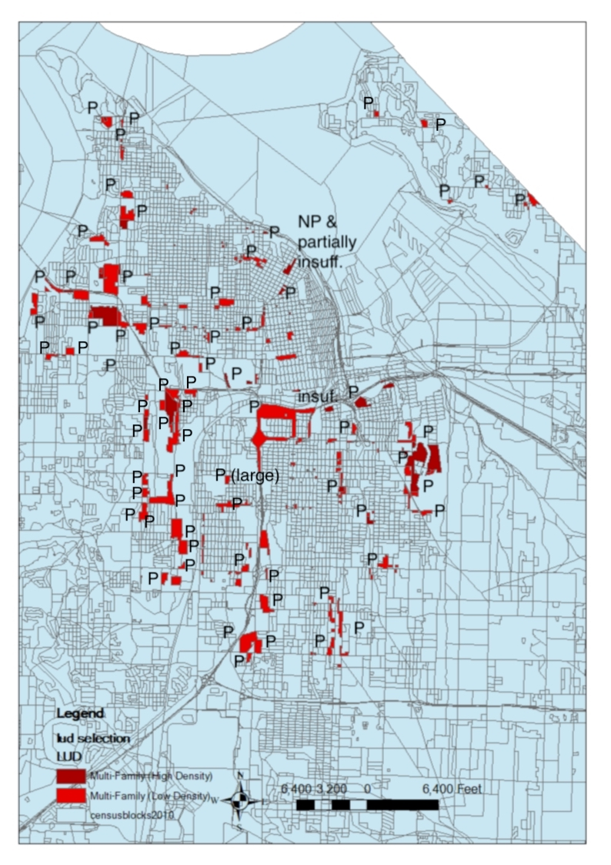

Figure 6 MUD Parking Situation in Tacoma (“P” standing for having surface parking)

**Considerations**

Following the background and initial analysis outlined above, several questions could be considered for recommendations about which incentives are best choices for Tacoma to increase the EV adoption rate. These questions are as follows: Which level of charging stations should be emphasized? What are some strategies used by other cities in regards to EV infrastructure? Does Tacoma need to treat renters and people who have to park on street differently? Are the incentives cost effective for different stakeholders like Tacoma Power, Tacoma government?

Variation with uncertainties - decision tree

One of the main source of problems when defining a strategy for an EVSE infrastructure is the uncertainty related to the EV readiness level of the buildings and the lack of information about what kind of upgrades would need to be made at every building to allow charging[7]. This leads to a very large variance in the expected cost for installation and operation of chargers. Most of this variance is caused by differences in the complex layout, the age of the complex and consequently its electricity grid and EV readiness. Furthermore, local constraints such as a need for disabled parking or fire alleys restrict the flexibility in finding a solution. In general, the organization of the parking space has a large impact on the solutions that can be implemented. Assigned parking spaces would rather make individual chargers appropriate, while unassigned parking spaces would probably lead to a higher appropriateness of shared charging facilities. Moreover, this requires further attention when deciding whether smart and multiplex chargers would be viable options as already mentioned in the previous section.

Factors mentioned above cause a strong variation in the estimated cost of the installation of operational EVSE charging stations. To illustrate this further, the decision tree shown in Figure below displays the charging options to install chargers based on the preferences and decisions of the owners and residents. This shows that the considerations for complexes with unassigned parking lots differ from the ones for assigned parking lots and that for the installation of charging solutions that charge the user based on their individual usage requires different charger solutions. While for assigned parking lots, every unit of the MUD could just get their own connection similar to practices used in single family housing, unassigned parking lots would often require the definition of charging zones with shared chargers. Especially for the latter case, multiplex chargers could be of high value. However, this report provides some estimates on the cost of installing the different elements that might be necessary to equip residents with EVSE. The following section provides a cost-benefit analysis, which is trying to show under what circumstances different acquisition and installation costs can be justified through lower recurring costs.

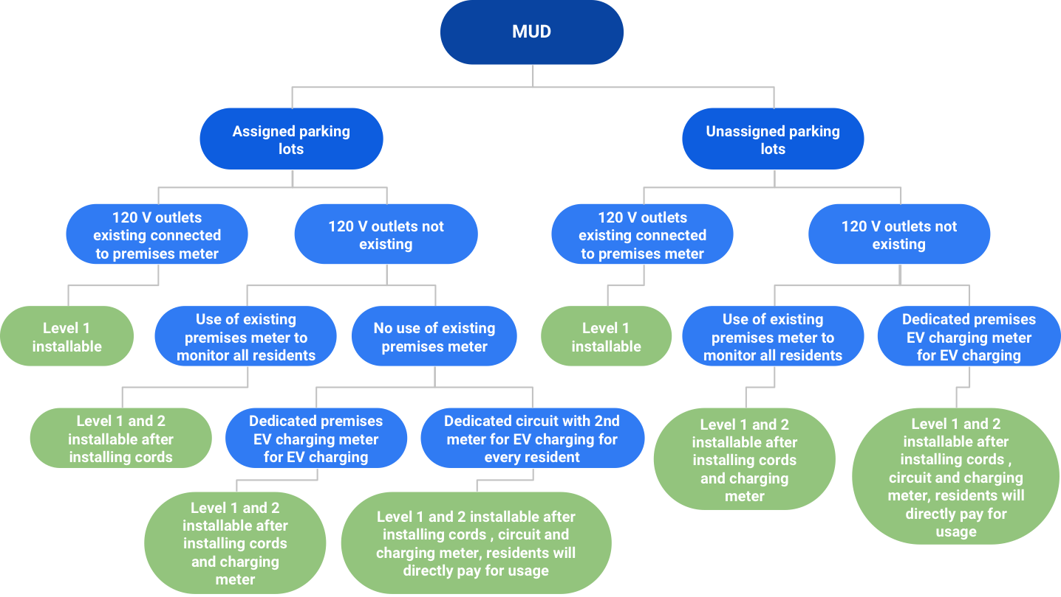

Figure 7 Options for EVSE charging infrastructure in Multi Unit Dwellings (MUDs)[8]

Charging station options

EV charging stations can be categorized into 3 categories: Level 1 (L1), Level 2 (L2), and DC Fast Charging (DCFC). The categories have increasing power output and thus can charge a vehicle faster. However, there is an increasing cost with each category and certain electrical configuration requirements in order to provide the power to the car. Typically only L1 or L2 chargers are suitable for home use due to cost and power requirements. Figure below displays some relevant information regarding the different chargers. For reference, a L1 charger draws power similar to a toaster, a L2 charger draws about as much power as a clothes dryer, and a DCFC can draw about as much power as a store.

With an EV purchase, a L1 charger will be included. However, it is possible to buy additional L1 chargers, either for convenience or because another may have better performance than the included stock charger. It is also possible to purchase a L2 charger for home use. In addition, a consumer can purchase a portable L2 charging cord, though an L2-capable station is still needed to provide the power. There are several factors that could influence whether a consumer wishes to rely on L1 or L2 charging at home. For instance, additional cost of an L2 charger, capacity and range of the EV, and typical driving needs and behavior could influence a decision to purchase an L2 charger over an L1 charger. There are potentially other factors as well, but more study would be needed to determine exactly what factors significantly contribute to a decision regarding charger choice.

Given that the market share of EV is still somewhat low, cities still have the ability to guide consumers to make certain decisions about their EV. The following paragraphs will discuss the advantages and disadvantages of the two charging levels for home use, and conclude with a recommendation for which charger the City of Tacoma should prioritize incentives.

Charging Level Information

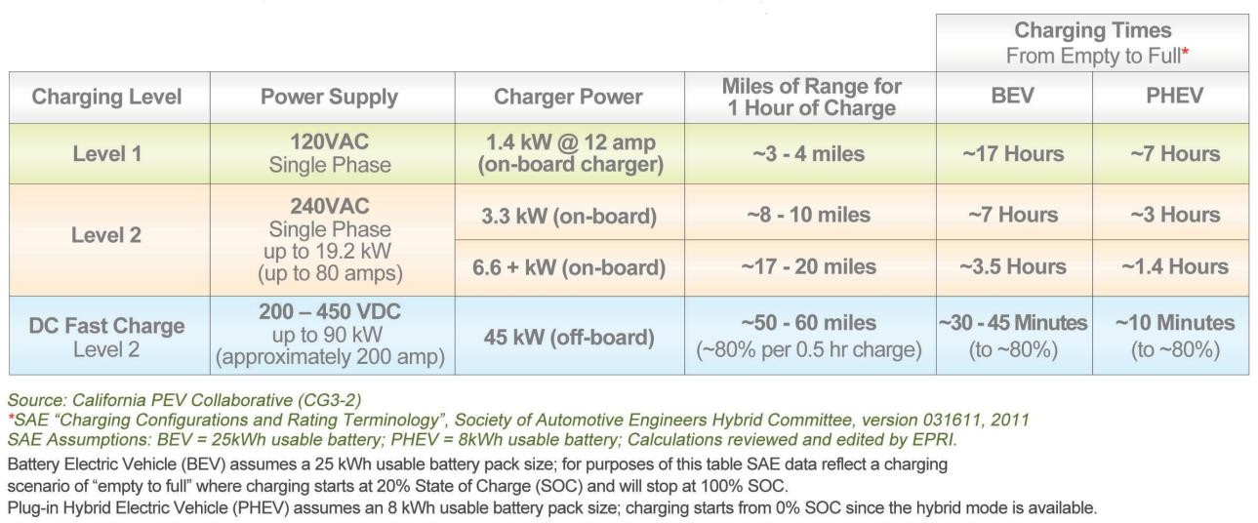

In terms of factors that impact which level of charger Tacoma should prioritize, there are also several aspects such as efficiency, effects on electric grid demand and distribution, cost of incentive programs, and future technology and needs. Several studies have shown that L2 chargers operate more efficiently than L1 chargers. For instance, Sears et al. found L2 chargers to provide an additional 6% efficiency during charge events than L1 chargers, and also found a 13% higher efficiency for low power charging which they defined as less than 4 kWh[9]. Another study by the Vermont Energy Investment Corporation found an average benefit of an additional 2.7% efficiency with L2 chargers and a 12.8% increase in efficiency for low energy use, which they defined as less than 2 kWh[10].

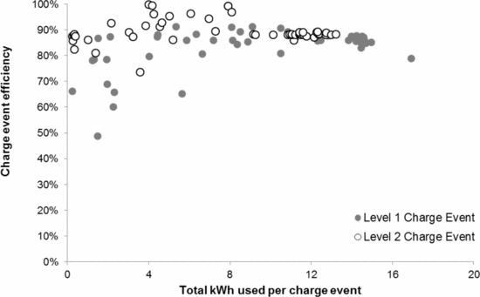

Figure 8 Level 1 and 2 charging efficiency[11]

This efficiency difference, coupled with the decreased total charging time, makes L2 charging an attractive choice. However, the decreased charging time with increased power usage causes some concern for balancing the electric grid network. It seems that a lower energy consumption spread out over a longer time would be easier to manage and certainly cause less spikes in demand. The spikes in demand would likely become less of an issue as more EVs are purchased in Tacoma, though. In addition, EV technology is improving and batteries have a growing capacity, thus extending the amount of time needed to charge even with a L2 charger in the future. The City of Tacoma needs to find a balance between preparing for the future and optimizing for current conditions. For this reason, it is still recommended to prioritize incentives for those wishing to purchase a L2 charger. One way to structure the incentive is to provide a Tacoma sales tax rebate for the base model of an EV purchased, if a L2 charger is also purchased.

According to the US Department of Energy, both Level 1 and Level 2 charging are appropriate methods for home-based charging[12]. Literature generally recommends the consideration of Level 2 charging for MUDs since the power output of most of these chargers can be configured to balance the power availability and the number of users. Additionally, the range gained after an overnight charge by a Level 2 charger is adequate for most daily drivers. Due to the higher utility rate, the higher installation cost can be amortized relatively quickly. In general, DCFC is seen as a technology that requires quite significant investments and requires high voltage and other prerequisites that are usually not given on private premises. Thus, it is more reasonable to consider up to Level 2 chargers for these users. However, if an installation of Level 2 chargers appears to be too costly or inappropriate for the given application, Level 1 charging is the minimum requirement for a widely distributed EVSE infrastructure[13]. More specifically, level 2 chargers that offer specific properties can be considered for MUDs as they offer substantial benefits to the users. One example are chargers that use smart charging cycles to delay the charging periods based on optimized cost to account for different electricity rates depending on the time of the day. Another technical option are multiplex chargers that allow charging multiple vehicles in parallel, which could be of particular interest for MUDs with multiple EV owners[14]. However, the applicability of these charging options is limited by the differences in technical challenges that appear on site.

Current policy reviews

19 out of 50 states in America have home incentives provided by local governments and utility companies for charging stations including rebates, tax credit, and permit waiver[15]. This is illustrated in Figure below. Note Washington state area is blank from the perspective of incentives, due to the recent expiration of the Washington state sales tax credit.

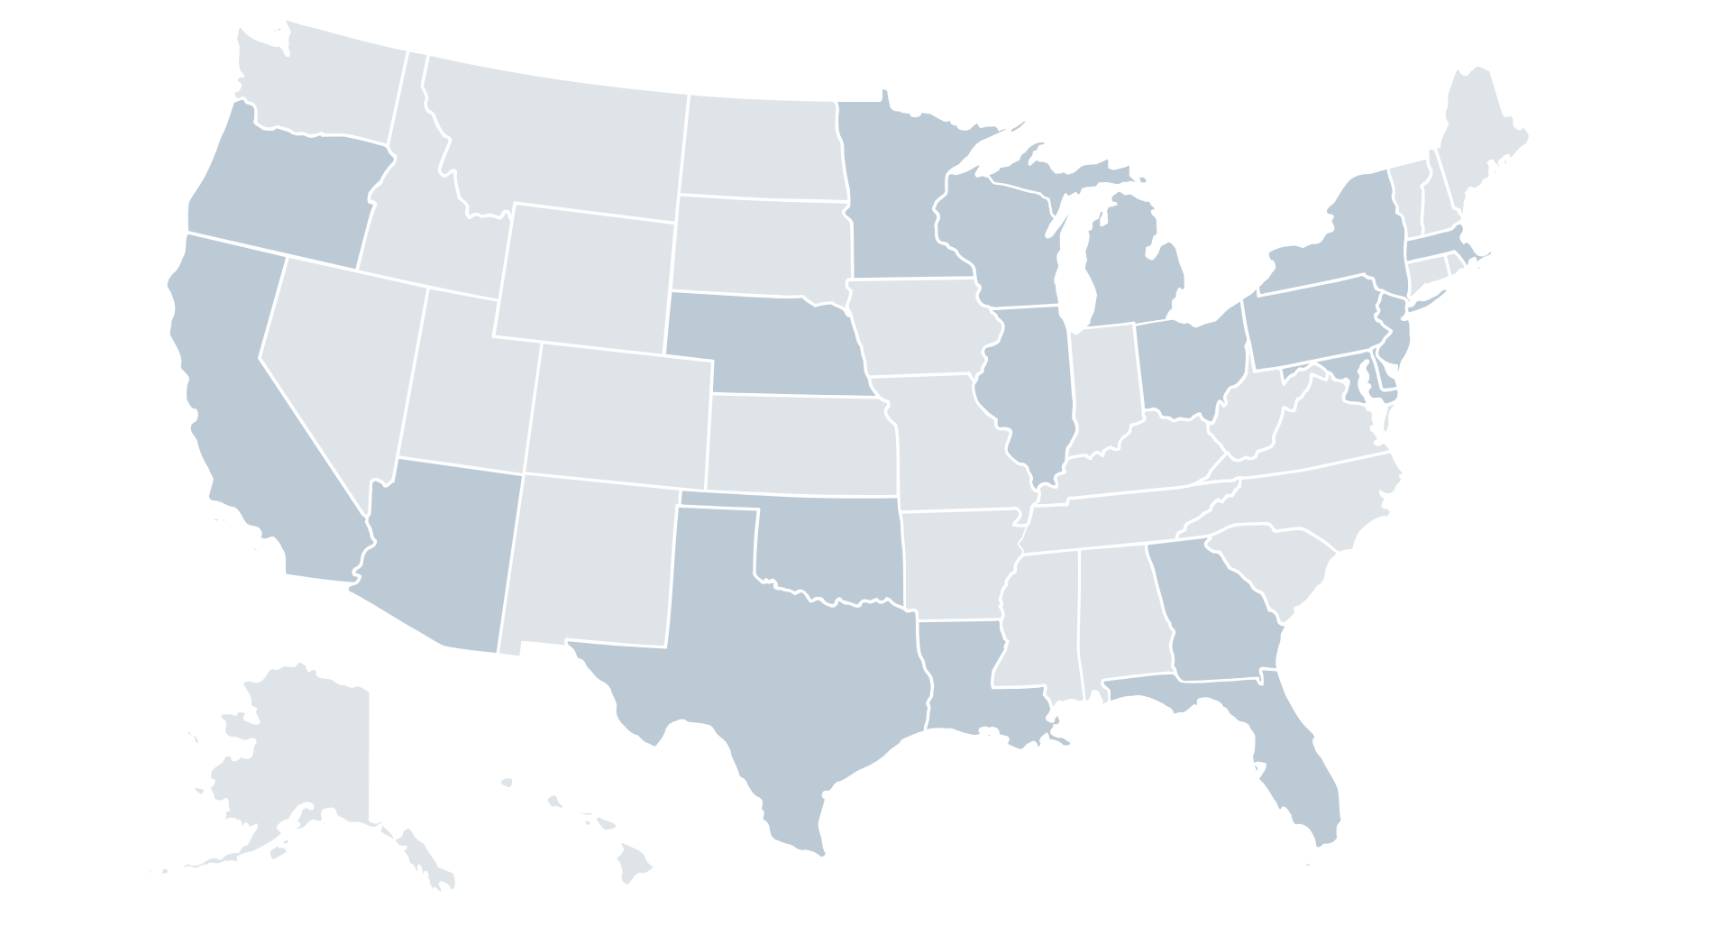

Figure 9 Maps of States with incentives for home charger stations

Among 19 states providing incentives, home incentives for level 2 charging station could roughly be divided into 3 categories: Rebates, Tax Credit, and Permit Fee. Besides different content, these three types differ from providers, phase of EV infrastructure, and incentives feasibility for Tacoma.

Rebates are mainly provided by utility companies in direct or indirect financial support, ranging from $150 to $750. The general design is that citizens sign up with the related power contract, and power companies promise to provide free L2 charging station or certain financial aid for the purchase phase or installation phase of EV charging station. For example, Anaheim Public Utilities EV Charger Rebate Program could give up to $500 to EV users that install Level 2 chargers at their property lots. But each person cannot redeem more than one rebate from Anaheim Public Utilities. Clearview Energy has multiple strategies to encourage people to install a Level 2 charger, including free charging during certain time periods (from 7 PM on Fridays to 7 AM on Mondays) and a $75 rebate for buying charging stations. It could also be possible for power companies to charge a different electricity rate for EV charging, which could form an incentive itself.

Tax credits are mainly provided by state government ranging from $75 to $1000. Many tax credits are only valid within a certain time period. For example, the tax credit from Louisiana State Government is up to 36% for the purchase and installation cost of an electric vehicle charging station if citizen install L2 charging station before June 30, 2018. Oklahoma residents are able to get one-time income tax credit which is up to 75% of the cost of an electric vehicle charging station project form the Oklahoma Alternative Fueling Infrastructure Tax Credit Program before January 1, 2020.

Waiving city’s permit fee related to the installation of the EV charger is a low-cost and feasible way provided by city government. For example, Anaheim will waive the city’s permit fee for the EV charger[16].

From 2016, State Building Code Council established a new code requiring new multi-family construction to accommodate EVSE installation. Where parking is provided, at least 5 percent of parking spaces must have EVSE infrastructure[17]. Besides, according to Washington State Department of Revenue, tax exemptions can apply for the labor and services rendered in respect to electric vehicle infrastructure[18]. Moreover, as for encouraging EV purchasing, a tax credit ($2,500 - $7,500) is offered by the federal[19] while Washington State gives a purchase and leasing tax exemptions ($2,600 - $3,100) on electric vehicles (excluding luxury electric vehicles)[20].

Based on precedent practice, incentives from utility companies are more recommended than incentives directly from city government or state government. On the one hand, by collaborating with charging station manufacturers and having more customers signing up for a several years energy plan, utility companies could see capital gains. Not all utilities operate in the same way, though, and it while some may need to make sure they remain profitable, it would be important to ensure customers are treated fairly. Other than utility companies, with a certain amount of budget, it still needs to be explored whether a city government could cost-effectively reduce sales tax on EV or provide incentive in some other way.

Owner-renter structure

There are some special considerations for residential homes in Tacoma, specifically in regards to EV adoption and feasibility. Two important considerations are renters and landlords, and those homes with no dedicated parking.

Housing characteristics in Tacoma from 2012-2016 American Community Survey 5- Year Estimates

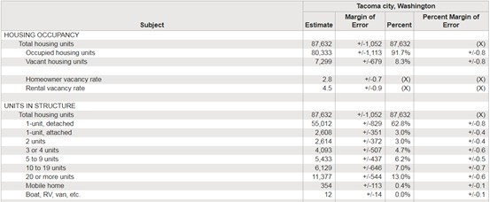

It could be noticed that Tacoma is a city with a high percentage of residential zones[21]. Except the harbors of New Tacoma and the commercial center in southwest and central Tacoma, most of the districts are marked as dwellings on the map. Referring to the housing structure statistics in the table, more than 65% of the residential houses are one family dwellings[22]. Under normal conditions, charging at home is convenient and inexpensive, most people might choose to do more than 80% of their EV charging at home[23]. Promoting accessibility of residential charging stations could be a promising direction of encouraging EV adoption.

State comparison of single family and rent households structures

|  |  |  |  |
| --- | --- | --- | --- |
| States | Colorado | Oregon | Washington |
| EV ownership (up to 2017) | About 11,238 | Over 11,910 | About 28,000 |
| Percentage of one family dwellings | 70% | 69.1% | 65% |
| Percentage of renter-/owner-occupied houses | 64.4% owner  35.6% renter | 61.4% owner  38.6% renter | 74% owner  26% renter |

Issues related to EV charging station installation, however, might be different for families who rent their house versus those that own their house, especially when they intend to install L2 chargers and some upgrade or adjustments to the house are needed. Not being able to make decision by themselves, renters, who would like to install an EV charging equipment at home, need to get permission from the landlord. As most of the incentives and policies (e.g., discounts in electric charges, installation fee rebate) aiming to increase EV ownership are targeting EV owners, the lessor of the house may be lacking in motivations to permit the installation of an EV charger because of the inconsistency of interests.

Given this, the question revolves around whether the city of Tacoma needs to take actions to encourage landlords to allow the installation of EV charger infrastructure from their tenants. About ¾ of the single house units in Tacoma are owner-occupied, while only ¼ are renter-occupied[24]. While single family home renters are not currently the majority group of single family home residents in Tacoma, it is still important to consider possible solutions for offering incentives to landlords, given that many of the 15,000 single family home renters may be interested in purchasing an EV and definitely MUDs have more renters.

Type of occupied units by tenure

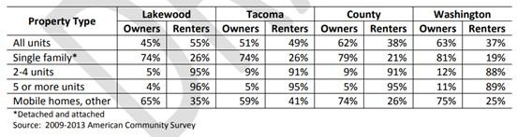

To avoid the loss of the landlord in EV charger installation, some states and cities take actions on policy and legislation. Referring to §38-12-601 of West's Colorado Revised Statutes Annotated, a tenant “may install, at the tenant's expense for the tenant's own use, a level 1 or level 2 electric vehicle charging system on or in the leased premises.” Meanwhile, the landlord “may require reimbursement for the actual cost of electricity provided by the landlord that was used by the charging system or, alternatively, may charge a reasonable fee for access.”[25] This statute guarantees that renters have the right to install an EV charger if needed, at the same time protect the economic interest of the landlords from potential loss during the installation process.

Similarly, in Oregon State Legislature 91.265, it also gives support to renters who are interested in getting access to a home charging station. It states that a tenant “may submit an application to install an electric vehicle charging station for the use of the tenant, employees of the tenant or customers of the tenant, in compliance with the requirements of this section, in, or accessible to, any parking space assigned to the tenant or the rental unit of the tenant,” and a landlord “may prohibit installation or use of a charging station installed and used in compliance with the requirements of this section only if the premises do not have at least one parking space per rental unit.” To protect the landlord, it also clearly states that “a charging station installed under this section is deemed to be the personal property of the tenant, and the tenant is responsible for all costs associated with installation and use of the charging station.”[26]

According to the data in May 2017, there were over 11,910 EVs on Oregon roads[27]. Similarly, by August 2017 there were 11,238 EVs in Colorado, while “over the first eight months of 2017 the EV sales were up 73% over the same period in 2016.”[28] Comparing with these two states, Washington State has higher EV ownership rate.[29] Besides, with the housing structure data shown in Table A-1 and Table A-2 (see Appendix), both the states have similar percentage of one family dwellings (70% in Colorado and 69.1% in Oregon) and renter-/owner-occupied houses (64.4% owner-occupied in Colorado and 61.4% owner-occupied in Oregon). It is possible for Washington State to consider similar statutes regarding to EV charging in rental families.

From the statutes above, it is clear that the main purpose of the regulation is to reduce the barriers for EV owners to access charging equipment, and provide enough compensation to the landlord who has no demand of the charger. In short, to encourage EV charger installation in renter-occupied houses, specifying and regulating the rights and obligations for tenants and landlords could be worthy. For Tacoma, this might not be the priority in pursuing EV adoption now, as a lower hanging fruit possibly is the owner-occupied population. Also, currently Washington State has not passed such kind of bill and the lawmaking may need time. However it might be a future direction. It would be suggested to lay the main focus of the infrastructure plan on incentives directly to EV owners, meanwhile submit related proposals to Washington State Assembly, council, or relevant department.

When thinking about how to optimally distribute incentives based on a given budget, it furthermore needs to be considered that the cost-benefit split varies significantly between single family households or condos and rental apartments as Figure below shows.

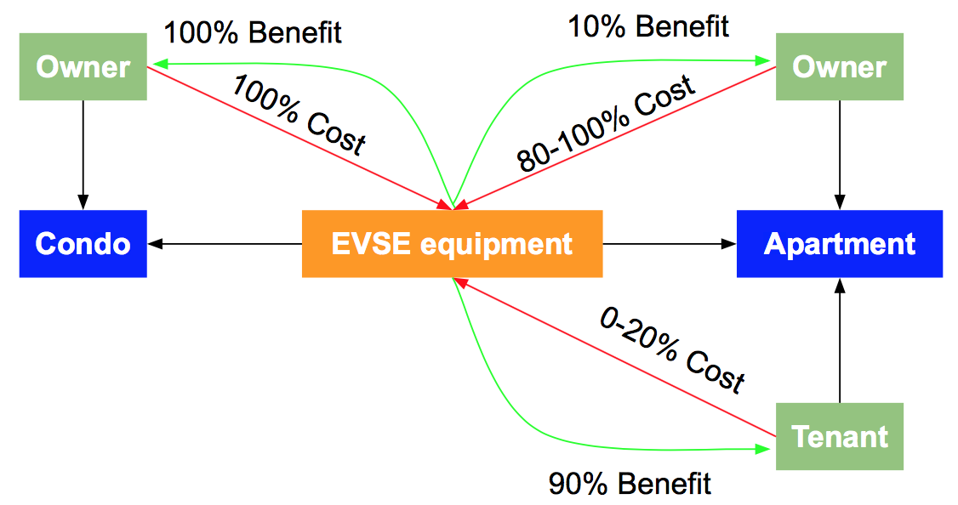

Figure 10 Expected cost-benefit split for condos and rental apartments

As visible, the investment for an installation of EVSE charging at a condo directly delivers its utility back to its investor. This is not the case for rental apartments as under regular circumstances a tenant cannot simply decide to install a new premises meter, make updates to the panel, etc. without any form of investment on the side of the landlord. Thus, the main investor behind EVSE installations is the landlord while the tenant receives most parts of the benefits. The landlord might receive a slightly higher rent or increase the attractiveness of their property. However, the main challenge is to put special emphasis on making the investment attractive to non-residing owners of the complexes.

EV charger readiness for MUD in Tacoma

Taking into consideration that the City of Tacoma has announced a target of 2000 registered EVs by the year 2020, it is necessary to find out how many of these should be owned by residents. Given the fact that, based on the ACS data mentioned in the introduction, roughly 30% of the Tacoma housing units are in MUDs, ensuring an equitable split, 600 of these EVs should be owned by MUD residents if the target should be achieved. According to a study that investigated the US residential charging potential for EVs[30], roughly 38% of households (particularly in urban areas) are basically capable of a charger installation. Considering that this is based on the assumption that around 79% of houses have dedicated parking facilities, and that the spatial map analysis that was presented in the introduction showed that around 95% of all MUDs in Tacoma have dedicated parking available, it is assumed that the EV capability of households can be adjusted as well. This would result in a charging capability rate (EV ready sites) of around 46% of MUDs. If this capability split would also apply to Tacoma and the corresponding MUD residences of to-be EV owners, it could be expected that 276 of the targeted EVs will be owned by residents of EVSE-capable MUDs, while 324 EVs will be owned by residents of currently EVSE-incapable MUDs.

**Cost-benefit analysis**

Cost estimation

Table below gives an overview on the estimated cost of installing equipment that makes a non-EV ready site EV ready, based on average data from HomeAdvisor[31]. It needs to be noted that these are average values that show a large variance due to the different circumstances at each building. Table shows cost estimates for the installation of EVSE infrastructure at EV ready sites for different charging solutions. These prices were taken from online stores AeroVironment, Inc and ChargeLab, with permit fees coming from the City of Tacoma[32][33]. In all cases, a local electrician should be consulted to identify a full scope of work depending on the current infrastructure and desired outcome.

Cost estimates for EVSE installations at non-EV ready sites

|  |  |  |  |  |
| --- | --- | --- | --- | --- |
| **Costs of getting EV ready\*** | | | | |
| **New Breaker Box** | **Labor** | **Permit Fees** | **New Meter** | **Total** |
| $75 | $800 | $135 | $200 | $1,210 |

*highly variable, depends on site conditions

Cost estimates for EVSE installations at EV ready sites

|  |  |  |  |  |  |
| --- | --- | --- | --- | --- | --- |
| **Installation of Level 2 chargers in EV ready sites\*** | | | | | |
|  | **Material** | **Labor** | **Permit Fees** | **Operation** | **Total** |
| **Level 2 (stand alone)** | $640 | $1,200 | $210 | Electricity | $2,050 |
| **Level 2 (stand alone, smart)** | $780 | $1,200 | $220 | Electricity, App | $2,200 |
| **Level 2 (2 plugs)** | $2,900 | $1,200 | $350 | Electricity | $4,450 |
| **Level 2 (2 plugs, smart)** | $3,100 | $1,200 | $350 | Electricity, App | $4,650 |
| **Level 2 (4 plugs, smart)** | $5,700 | $1,200 | $430 | Electricity, App | $7,330 |

*highly variable, depends on site conditions

Based on the information above, it could be estimated the expected total cost of equipping the selected number of residents with an EVSE infrastructure. Table below shows the results of the calculations based on the assumption that regular level 2 chargers are installed per vehicle. Since the cost of the charger is almost perfectly correlated with the number of plugs and shared chargers would almost impose the same cost per EV, this assumption would be reasonable.

EVSE installation cost estimates for Tacoma for 2020 EV target

|  |  |  |  |
| --- | --- | --- | --- |
| **Action** | **No. of units** | **Cost per unit** | **Total cost** |
| *non-EV ready MUDs* |  |  |  |
| EV-readiness of non-EV ready MUDs | 324 | $1,210 | $392,040 |
| Charger installation  (assuming regular, Level 2 chargers) | 324 | $2,050 | $664,200 |
| *EV ready MUDs* |  |  |  |
| Charger installation  (assuming regular, Level 2 chargers) | 276 | $2,050 | $565,800 |
| Total cost |  |  | **$1,662,040** |

As the table shows, an estimated cost to equip a sufficient amount of MUDs with EVSE charging to achieve the 2000 EVs target by 2020 is roughly $ 1.7 million. This underlies some restrictions. It imposes that MUD complexes will only be equipped if it directly follows that there will be a new vehicle to charge following this installation. Therefore, this is a best case scenario. However, this is balanced out by not considering the number of EVs that are already registered in Tacoma today. Thus, it could be expected that if the 600 MUDs can be equipped with EVSE, the Tacoma target is attainable. This information will be used to determine the structure of the policy incentives in the following sections. If the cost should be restricted to this amount, the applied policies need to make sure that there is a cap, such that only these 600 MUDs will be equipped, otherwise the cost might sum up higher, while overachieving the target.

Scenarios in terms of owner - renter structure

To assess how rebates can be applied in the proposed policies, it needed to be analyzed how the expected benefits through the installation of a charger compare to their cost and calculate a break-even point. This analysis assumes EV-ready buildings and will be based on the outcome of the previous sections and the fuel cost reduction achieved by using EVs, plus the installation cost of the chargers. This break-even point heavily depends on the individual situation (condos or single family households, apartments, owner-renter relationships, etc.). Assuming annual changes of gasoline and energy prices and an annual discount factor of 6%, four different example cases were provided:

**Case 1:** Condo or single family household - Owner invests into the installation of one charger for personal use

**Case 2:** Mixed Condo / Rental apartments (condo owner owns 5 additional units in the building and rents them out to tenants) - Owner invests into multiple chargers and uses one of them

**Case 3:** Rental apartments - Landlord invests into a set of chargers (in this case 6 chargers), while not using any of them for personal use and receiving a commission of 20% of the benefits generated through the chargers

**Case 4:** Rental apartments **-** Sharing chargers with case 3 above - 12 renters are sharing 6 installed chargers (2 renters share 1 charger)

These cases all assume that the installed chargers will be used such that the upfront cost for a charger (level 2 stands alone) is $2,050 for charger ready sites. The net present value (NPV) and discounted payback period (DPP) were measured for each scenario. It is assumed the annual vehicle miles travelled to be 10,230 miles per vehicle[34] and an average MPG of 33 according to the standard applied to the year 2017[35]. Thus, an internal combustion engine (ICE) vehicle requires 310 gallons of fuel on average per year. The total cost was calculated to be $772 per year based in a fuel price of $2.49 / gallon[36]. For EVs it is assumed the same mileage and a fuel economy of 30 kWh / 100 miles (34 kWh/ 100 miles for Tesla models S - 90D, 30 kWh/ 100 miles for Nissan Leaf, 32 kWh/ 100 miles for Kia Soul). Thus, the annual energy requirement is 3069 kWh. Based on a price of $0.077/kWh[37] the annual cost is calculated as $236.30, which results in an annual benefit in operational cost of $535.70 per EV. For case 1, it is achieved break-even within less than 6 years, which is reasonable as the investor directly receives their Return-On-Investment (ROI). In each case, Net present value (NPV), present value (PV) and future value (FV) would be measured. This is a case comparable to single family housing EVSE.

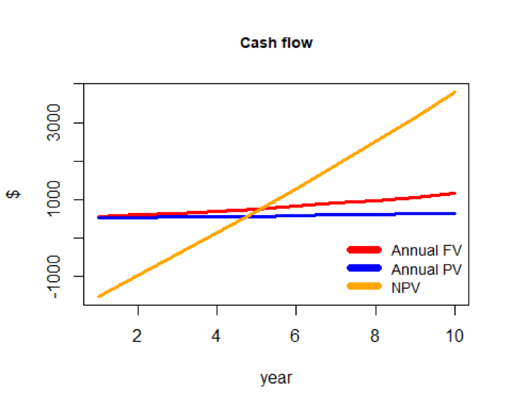

Figure 11 Case 1, Break-Even (Condo), (Note, FV: future value, PV: present value)

For case 2, the break-even will not be reached before 20 years after the investment. Case 3 assumes that the landlord does not live in the building and receives a commission of 20% of the installation cost, in the form of increased property value and/or rent increases that are possible due to the higher attractiveness of the property. Also, in this case, the break-even will not be reached until around 18 years, as Figure below shows.

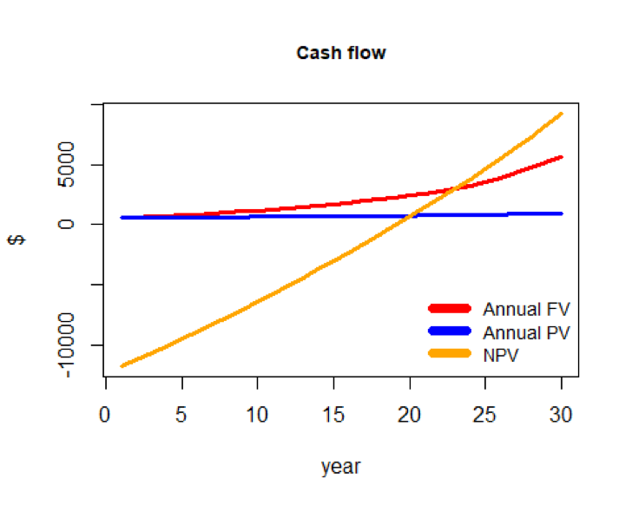

Figure 12 Case 2, Break-Even (Mixed condo-rental apartment)

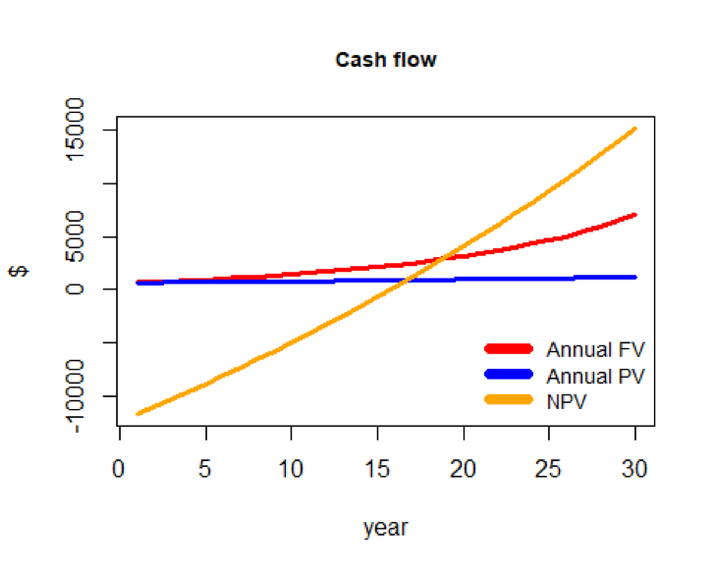

Figure 13 Case 3, Break-Even (Rental apartments)

Since the case 3 assumes that every charger will be used by one tenant, assuming assigned parking lot charging, it is furthermore provided with an alternative approach (case 4) for 12 rental units that share 6 chargers. In case 4, the break-even can be reached within 10 years, as Figure below shows. Cases 2 and 3 clearly indicate that the break-even point for rental apartments is difficult to reach. Thus, if the city of Tacoma aims for making EVSE attractive to rental complexes, the incentives will have to be much higher to motivate landlords to invest. Even after taking into account the possibility to share chargers, such as in case 4, it is still insufficient to mobilize the landlords to install EVSE without additional incentives. As outlined previously, this assumes EV-ready buildings, the time until break-even will be reached is even longer for installing in non-EV ready buildings.

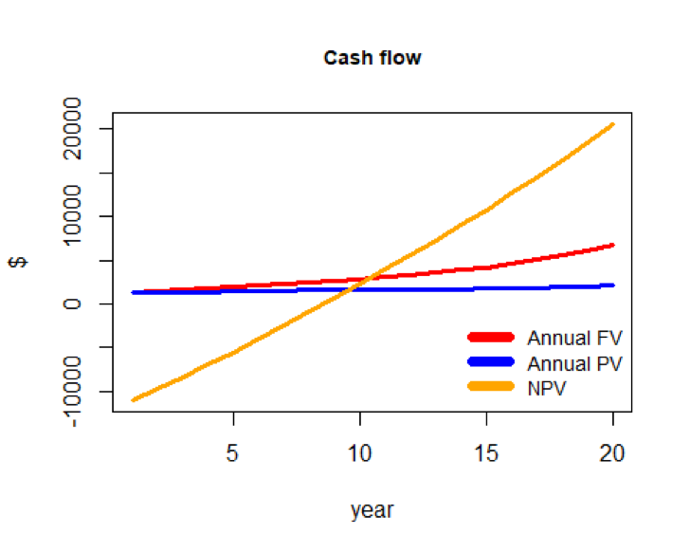

Figure 14 Case 4, Break-Even for Case 3 with shared chargers (Rental apartments)

In summary, as the simulations show, to get a benefit through the installation of chargers at MUDs that is comparable to the benefits at single family households, it is necessary to create a mechanism to collect commissions for the benefit coming from EV chargers like the case 3 where the landlord collects 20% of benefit generated from the renters using chargers. Moreover, rather than one assigned charger, sharing chargers with other renters like the case 4, would enhance the pay-off dynamics, thus would lead to an earlier expected break-even point.

Rebate options

As the previous cost benefit analysis shows, in order to make the investment of chargers as effective as for single family households, there should be support to MUD owners who need to invest their private funds for the installation of chargers. Taking into account the previous case analysis, a DPP of 4 years should be targeted if it is aimed at achieving a similar benefit as for case 1. This section investigates how high the incentives would have to be to achieve this goal for case 2, case 3 and case 4.

For case 2, the incentive would have to be at least 80% of the upfront cost. Figure below shows that an incentive of 50% would still not be enough.

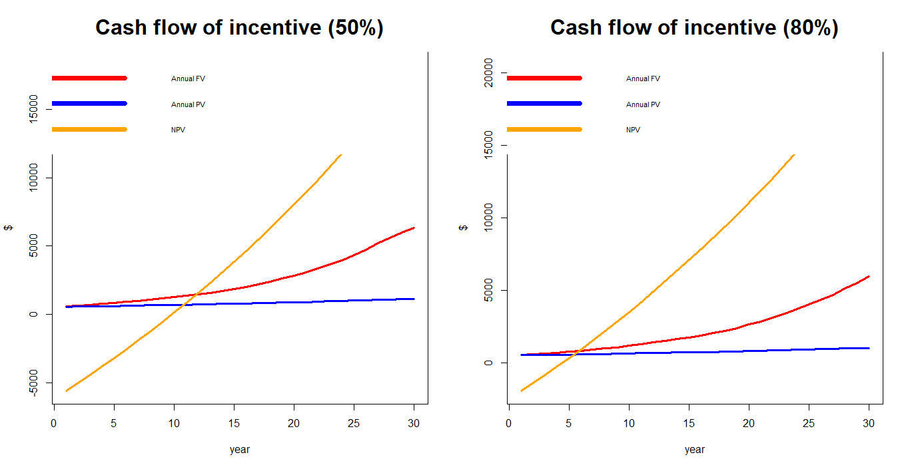

Figure 15 Incentive estimation for case 2 to reach as the same as case 1

For case 3, the results are very similar, as visible in Figure below. Hence, both case 2 and case 3 would require an incentive to cover around 80% to receive a comparable DPP as single-family household or condo owners receive.

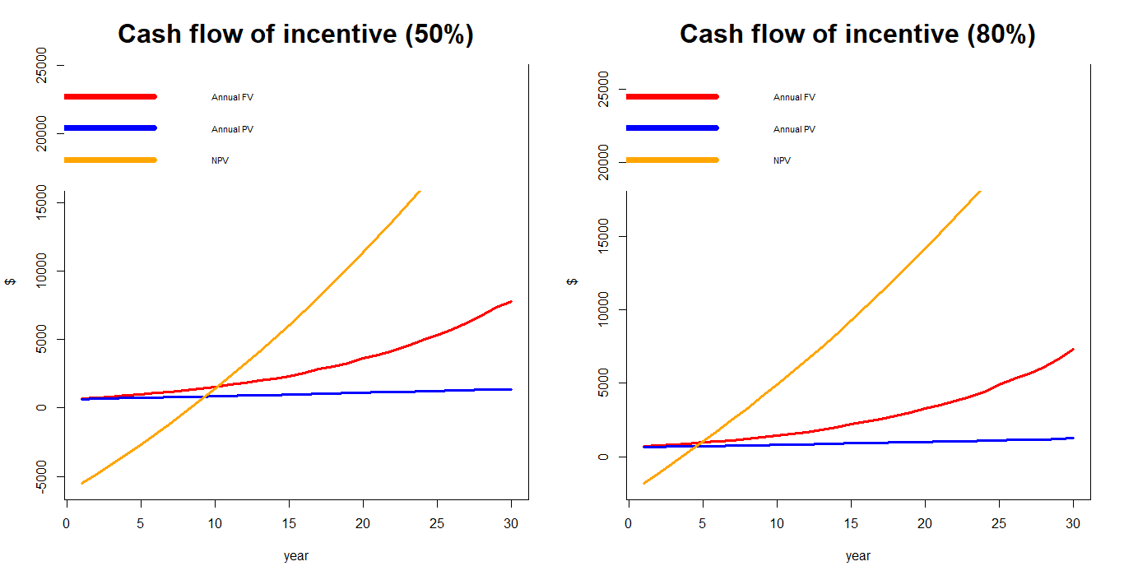

Figure 16 Incentive estimation for case 3 to reach as the same as case 1

However, if the commission increases to 50%, the incentive could be relaxed from 80% to 40% to meet the DPP of 4 years. With the same commission of 50%, having no incentive still meets a DPP of 8 years. This shows that collecting a commission fee is more effective than incentivizing the upfront cost of installation of chargers.

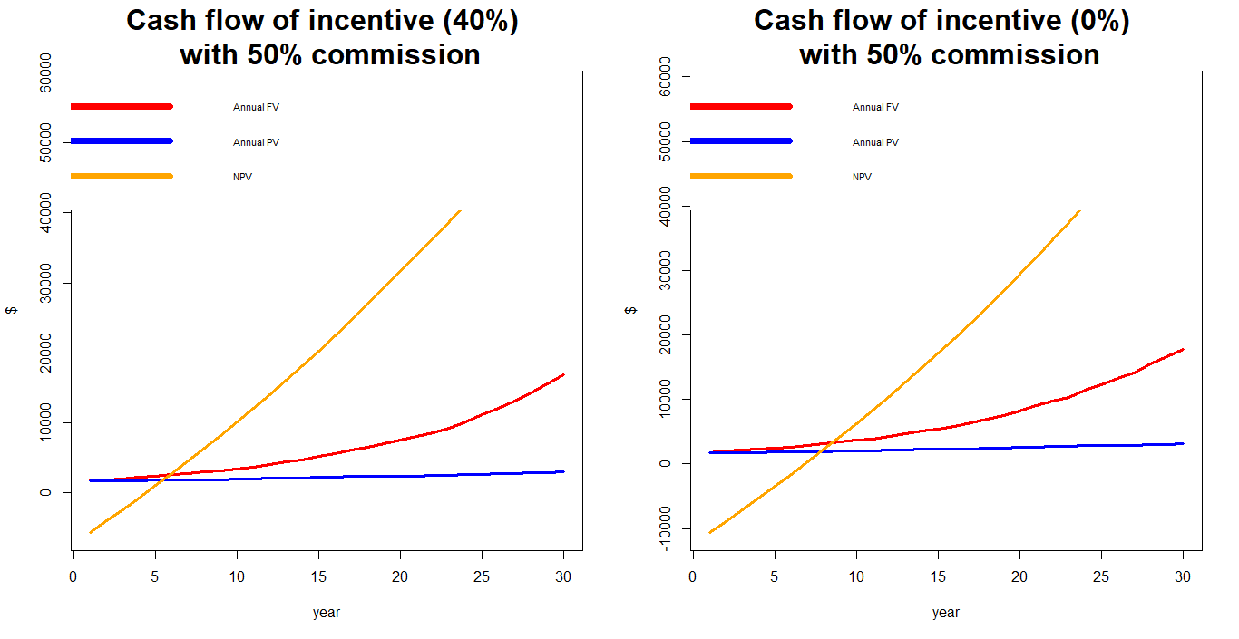

Figure 17 Incentive estimation for case 3 to reach as the same as case 1

Adding a 60% incentive of upfront cost to case 4, shows a DPP of 4 years, which can also be achieved through changing the commission fee to 50% as Figure below shows. It also confirms that commissions are more effective to reach the goal of a shorter DPP than incentivizing the upfront cost. However, it is necessary to take into account that increasing the commission fees will heavily decrease the benefit to the renter of the apartments, which can result in equity issues for lower income groups as this could make switching to an EV infeasible for these groups. Thus, it is not recommended to motivate landlords to increase commission fees from an equity perspective.

Furthermore, it was found that sharing chargers by two, is as effective as collecting commissions. By increasing the number of users for a given charger it can enhance the mechanism for owners to reach shorter DPP. By optimizing the utilization rate of chargers depending upon the local conditions, it can reduce the commissioning rate while getting the same result and thus deliver added value to both the renter and the landlord.

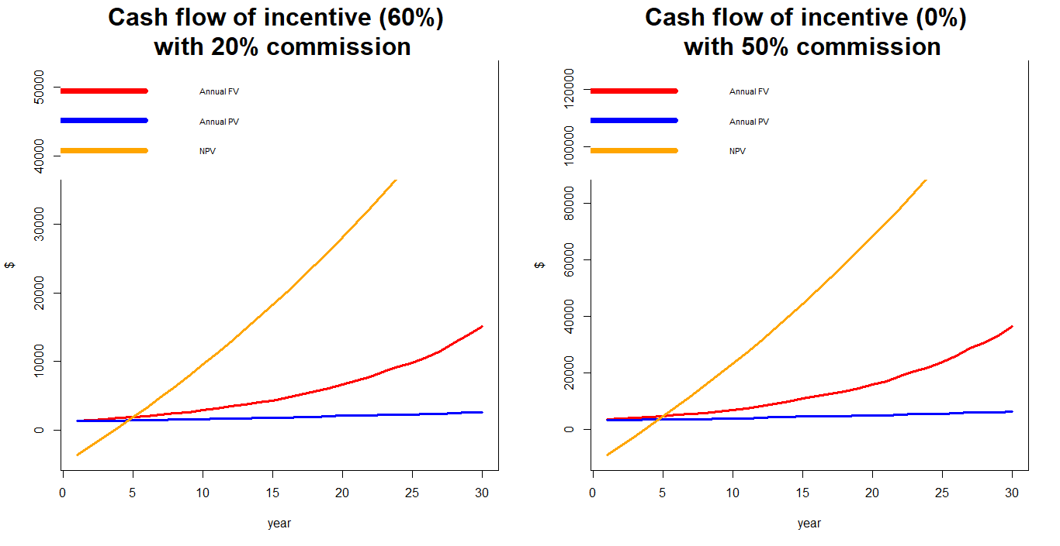

Figure 18 Incentive estimation for case 4 to reach as the same as case 1

Summary of incentives needed for each scenario (DPP targeting at 4 years)

|  |  |  |  |  |  |
| --- | --- | --- | --- | --- | --- |
| Scenario | Scenario 1 | Scenario 2 | Scenario 3 | Scenario 4 | Scenario 5 |
| Case | Case 2  Mixed condo | Case 3  Rental  apartment | Case 3  Rental  apartment | Case 4  Rental  (sharing charger) | Case 4  Rental  (sharing charger) |
| Commission rate | 0% | 20% | 50% | 20% | 50% |
| Rebate rate needed under each scenario in order to achieve a DPP of 4 years | >= 80% | Around 80% | Around 40% | Around 60% | 0% |

**Policy analysis**

Policy framework

Assuming that the monetary capacity to motivate the installation of chargers is limited, it was seen as valuable to offer a set of options to further focus the direction of the incentives and optimize the outcome based on the objectives of the city of Tacoma. As already mentioned, the City of Tacoma aims at finding solutions that achieve their goals most effectively and equitably. Based on which of these two parameters is seen as more important, different policies could be designed. After having shown in the cost benefit and rebate analysis that similar results can be gained through different approaches, it was decided to offer options to go down either a route optimizing equity or one optimizing efficiency. Conditional on the available budget it could even be possible to combine them into one approach. This approach follows the idea of a fairness model that balances equity and efficiency for policy making, which was part of a research paper by McCoy[38]. McCoy applied the model to health delivery fleet management, but it could be applied to this case as well. The basic model defines two objective functions (one to maximize efficiency and one to maximize equity) that are applied to a set of capacity constraints. Applied to this case, depending on the parameter **α** >= 0, either the efficiency or effectivity function would be applied with **β** describing the relative utility of installing a charger at unit **x**. Through changing the value of **α**, the balance between efficiency and equity can be controlled. The available budget is determined by the parameter m that restricts the cost over all units. **C** represents the cost of installation per case **i**.

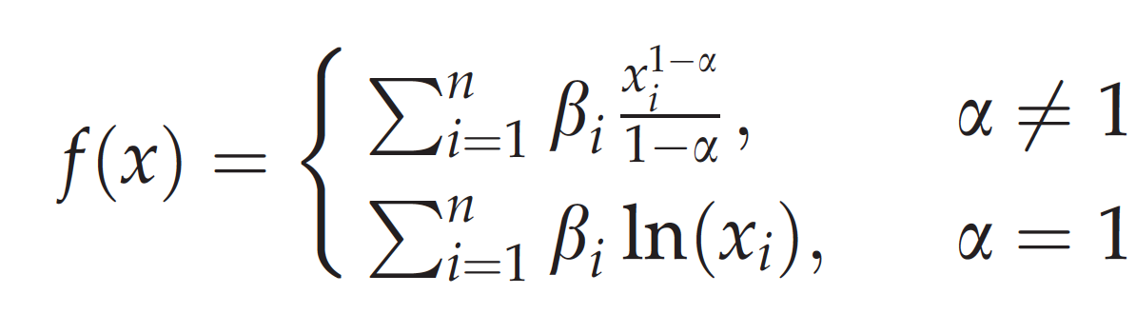 

To further investigate which part of the residents to focus on to achieve this, the cluster analysis performed in the beginning was reviewed. The residents of Tacoma MUDs can be separated into two clusters. Households that belong to one cluster (cluster 2), on average have a significantly lower education level, lower income, lower rental apartments and exhibit a high proportion of single households. Due to these factors, this group is more likely to live in less well equipped and older buildings, which require higher investments to install EVSEs, despite the cost benefits through using an electric vehicle would be similar to higher income parts of the population.

Supporting these residents through subsidizing an update of these buildings to EV readiness, would give better access to electric mobility to less privileged groups of people and would therefore be an equitable approach. This could be reached through assigning rebates to specific actions that could be taken to update a house, such as an update of the electric circuits, or the equipment of parking lots with plugs and cables. Thus, incentivizing basic building updates would reduce the variance in between the buildings and could motivate landlords and condo owners to pursue the last steps, such as the installation of a charger, on their own.

The other cluster (cluster 1) can be characterized by a higher income level, a dominance of family households, smaller MUD complex sizes and a higher proportion of condos. This group is much closer to the typical EV owner characteristics[39] and thus, the likelihood for these people to actually invest in the installation of EVSE and the acquisition of an electric vehicle is higher. In addition to this, the residences of higher income groups are more likely to have more recent build years and are therefore EV ready. Targeting the policies to the needs of this group is therefore a more efficient approach. This is helpful, if the aim is to primarily maximize the number of chargers and electric vehicles on the road. Since these incentives probably would not be sufficient to decrease the financial gap for lesser equipped buildings to a level that makes them invest into EVSE, this will leave more budget for equipping modern buildings and can therefore maximize the number of available MUD chargers.

However, the outcome of the McCoy’s study has shown that following a relaxation of the capacity constraint (assignment of a higher budget), the equity target could be achieved while holding the efficiency at a high level. Thus, taking into account the long-term effects, an expansion to both approaches could be taken. The following section shows how the effect of the different approaches can be estimated.

Policy effect is analyzed based on a case that assumes the installation of stand-alone level 2 chargers ($2,050 installation cost) with a budget limited to 100 chargers (i.e. $205,000), For the eleven MUD block groups that were defined in the cluster analysis for Tacoma, three of them related to the higher income cluster (1) while cluster 2 is more related to the characteristics of the remaining 8 block groups. To keep this analysis within simple bounds, it is only consider the ownership structure cases 1 and 2 from the cost benefit analysis.

Based on the identified renter and owner distribution structure of the MUD block clusters 1 and 2, the cluster 1 (i.e. 3 block groups) are assumed to include 30% of MUDs with the case 1 structure and 70% of the case 2 structure; cluster 2 (8 block groups) is assumed to have 10% of the case 1 structure and 90% of the case 2 structure.

The aim of the following analysis is to check how different social or rent household structures in MUDs affect the outcome of the selected policy application in terms of efficiency and equity. It is considered a cash flow time horizon of 20 years to receive an average expected NPV per unit charger. Furthermore, based on the population of each block group, each of them was weighted in proportion to its population assuming that the EVSE demand is proportional to the population, which is shown in Figure below.

These benefit weights were added to the objective functions of the maximization problem. The policy parameter α was set to different values depending on the policy goals. The efficiency-oriented policy seeks to maximize the benefit by focusing more on efficiency. By concentrating on cA_1, cA_2 and cA_3, which happen to be all cluster 1, the maximized benefit in terms of saved energy turns out to be $446,695 for a 20-year time horizon (left in Figure below). This is the maximum benefit from installing 100 chargers. Thus, focusing on these block groups would maximize the efficiency.

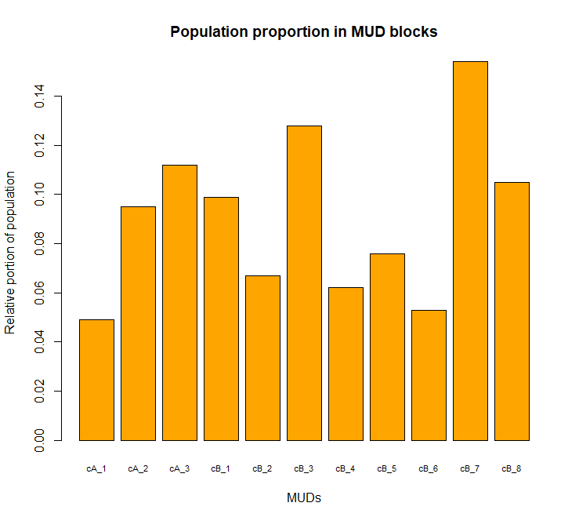

Figure 19 Population proportion in MUD block groups (cA is cluster 1, cB is cluster 2)

On the other hand, the equity policy seeks to maximize the benefit while focusing more on equity. The optimal solution was found and the expected benefit in terms of saved energy is estimated to $78,191 over a 20-year time horizon. This benefit is far lower than for the efficiency policy while it improves the equal resource allocation for all MUD block groups regardless of which cluster they are belong to (right in Figure below).

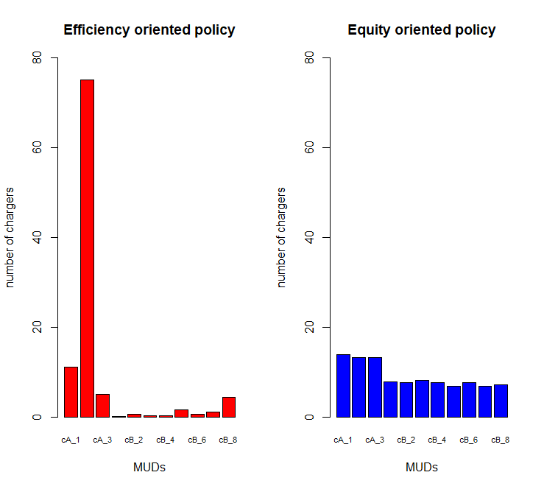

Figure 20 Efficiency and equity-oriented policies for the limited charger allocations for given 100 chargers

Equity and efficiency oriented policies

Taking into consideration the previous analysis, the objective of the equity strategy is to support MUDs through decreasing the financial gap that motivates landlords and condo owners to successfully install EVSE charging. This will reduce the variance in EV readiness levels in between the MUDs in Tacoma. Based on the cost benefit analysis for EVSE installation it is necessary to take into account that rental apartments require more attention than condos, especially for upgrading to EV-readiness. Therefore, the focus lies on providing support for basic upgrades of the buildings and distribute them across as many complexes as possible, instead of just supporting the installation of chargers for condos and rental apartment complexes. The cost benefit analysis has shown that rental apartments require between 50 and 80% upfront cost incentives to make the investment as attractive to landlords as it is to condo owners, even if the building is already EV ready. Taking into consideration that shared chargers can significantly shorten the DPP and decrease a need for commissions, it could be accepted with a longer DPP through slightly lower rebates in between 30 and 50% to ensure affordability and reasonableness. This could be compensated through the individual decision of the landlord to apply a commission rate through a higher rent and the proposed property tax cut.

Equity oriented EVSE strategy incentives

|  |  |  |
| --- | --- | --- |
| **Incentive (Rebate)** | **Condos** | **Rental Apartments** |
| Streamlined permit process with fee waivers | X | X |
| Update to EV readiness   * Equipping assigned parking lots with electricity and plugs * Equipping unassigned parking with electricity and plugs * Installation of dedicated parking lot premises meters | 20% | 50% |
| Installation of regular Level 2 charging stations | 20% | 30% |
| Optional C-PACE city financed and operated EVSE[40] |  | X |
| Annual property tax reduction for EVSE installations | - | 10% |

As Table shows, the objective of the equity strategy focuses mostly on incentivizing rental apartments as the motivation for landlords of lower income rental apartments is expected to be the lowest as the expected return on investment (ROI) is lower due to the lower rent. Additionally, it is recommended that providing a service such as C-PACE [26], to offer an alternative option for the landlords to finance EVSE installation. It needs to be noted that the percentages applied to this policy are based on good judgement of the authors and do not imply optimality as the amount of uncertainty makes it inappropriate to search for a theoretical optimal value. The general behavior was shown in the policy effect analysis. The gaps in between the rebates and which MUD types and actions should be pursued represent the importance of financial support, while the values themselves are proposals and modifiable based on the available budget. This follows the logic of providing higher incentives on elements that have the lowest ROI and that are blocking landlords from investing. However, the policy cost estimates were based on these percentages.

The objective of the efficiency strategy is to maximize the number of charging stations in the city of Tacoma and thus offer EVSE to as many MUDs as possible at a limited budget. This should be achieved through the installation of smart charging devices at buildings that are well equipped to support these chargers. Since the analysis showed that rental apartments would require a much higher incentive investment than condos, it is more efficient to focus on condos. However, since rental apartments from investing would need to be included, the same incentives will also be available to apartment complexes.

Efficiency oriented EVSE strategy incentives

|  |  |  |
| --- | --- | --- |
| **Incentive (Rebate)** | **Condos** | **Rental Apartments** |
| Streamlined permit process with fee waivers | X | X |
| Installation of regular charging stations (cap at $600 per plug) | 20% | 20% |
| Installation of smart station (cap at $1000 per plug) | 30% | 30% |
| Special electricity fare for EVSE usage | 20% | 20% |

As visible in Table above, the incentives focus on motivating the installation of chargers. Thus, every dollar that is invested will also lead to the installation of a charging station. On average due to the DPP of less than 6 years, a rebate of 20% was seen as sufficient. However, to foster the use of smart charging stations to even further improve efficiency and balance out the energy demand, these will be incentivized at a rate of 30%.

Applying the policies presented based on the results given before, we end up with the following policy cost estimates:

Equity policy cost estimates when capping at 600 incentivized cases based on average values

|  |  |  |  |  |  |  |
| --- | --- | --- | --- | --- | --- | --- |
| **Action** | **MUD type** | **Assigned cost** | **Rebate** | **Policy cost** | **Est. no. of residences\*** | **Total action cost** |
| Upgrade to EV readiness | Apartments | $1,210 | 50% | $605 | 275 | $166,375 |
| Condos | $1,210 | 20% | $242 | 49 | $11,858 |
| Installation of regular level 2 charging stations | Apartments | $2,050 | 30% | $615 | 509 | $313,035 |
| Condos | $2,050 | 20% | $410 | 91 | $37,310 |
| Property tax cut | Apartments | $3,130** | 10% | $313 | 509 | $159,297 |
| **Total cost** |  | | | | 600 | **$687,875** |
| *estimated based on the estimated splits between EV ready and non-EV ready buildings and the cluster analysis outcomes  **based on an average MUD unit value of $253,000[41] and average property tax of 1.237%[42] | | | | | | |

Efficiency policy cost estimates when capping at 600 incentivized cases based on average values

|  |  |  |  |  |  |  |
| --- | --- | --- | --- | --- | --- | --- |
| **Action** | **MUD type** | **Assigned cost** | **Rebate** | **Policy cost** | **Est. no. of residences\*** | **Total action cost** |
| Installation of regular level 2 charging stations | Apartments | $2,050 | 20% | $410 | 305 | $125,050 |
| Condos | $2,050 | 20% | $410 | 55 | $22,550 |
| Installation of smart level 2 charging stations | Apartments | $2,200 | 30% | $660 | 204 | $136,640 |
| Condos | $2,200 | 30% | $660 | 36 | $23,760 |
| **Total cost** |  | | | | 600 | **$308,000** |
| *estimated based on the cluster analysis results and on the assumption that 40% will opt for a smart charger | | | | | | |

The cost of applying the equity policy can be estimated to around $690,000 ($1,150 per charger installed) and the efficiency policy at $310,000 ($516.67 per charger installed). This shows as expected, that optimizing for equity is correlated with a higher cost for the city administration (in this case 120% higher) to reach the same amount of installed chargers. While the cost estimates are based on averages and underlie uncertainty, they are suitable to provide an outlook on the expected cost, but should not be used for direct budget allocations. Based on Tacoma’s objectives, they now have the option to decide which way appears to be the most appropriate for them. In case of a higher budget and an aim to achieve more than 600 new EVs through MUDs, of course both policies can be applied simultaneously or in a two-step approach optimizing for efficiency in a first step and for equity in a second step to reach the GHG reduction targets as quick as possible.

Peak demand strategies

44 utility companies in America provides discounted rates, rebates or other incentives to increase electric vehicles adoption. Moreover, the time-of-use rates provided by over 200 utility companies across the country serves as the similar incentive and makes EV charging more affordable[43].

It is self-evident that the increasing EV adoption has significant social benefits like reducing green gas emission. From the perspective of utility companies, encouraging EV users to charge at home can also bring direct and indirect benefit for them. In the short run, utility companies may spend some money on upgrade electricity infrastructure if the increasing electricity demand caused by EV charging is overload the current capacity. But in the long run, the cost of generating electricity will shrink with the increasing share of EV.

The electric demand disparity between the peak hour and off-peak hour consists of the electricity cost. Encouraging off-peak EV charging is not only could make charging at home more affordable but also reduce the cost of utility generation, transmission and distribution infrastructure[44].

From Figure below, the electricity demand in midnight to early morning is lower than demand in daytime. This is because citizens fall asleep and close many electrical products such as lights and TV during the night. To shrink the difference, many utility company provide time-of-use program (TOU) which gives lower rate for people who use electricity at night.

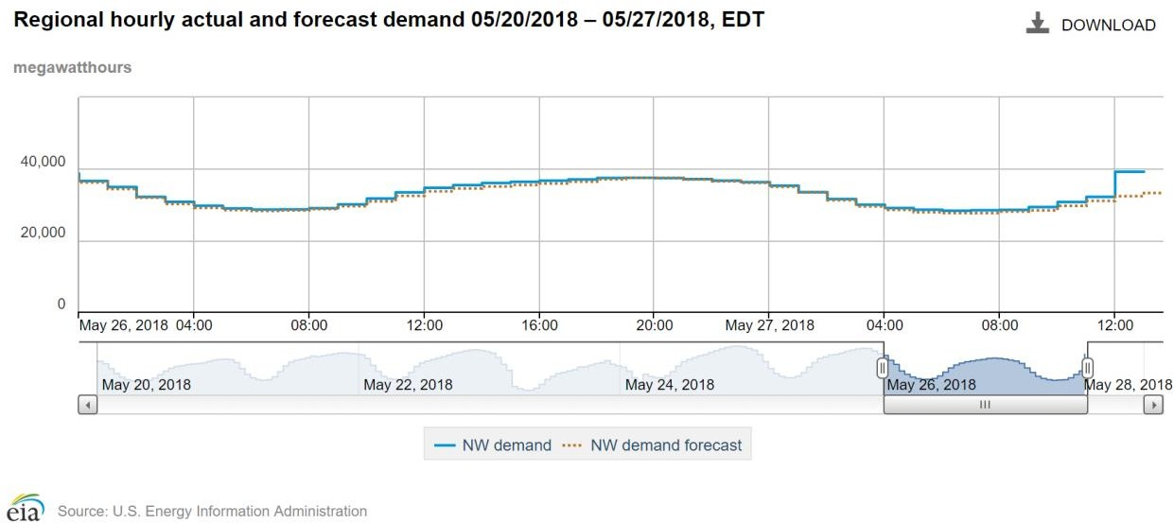

Figure 21 City of Tacoma daily electricity demand curve on May 28

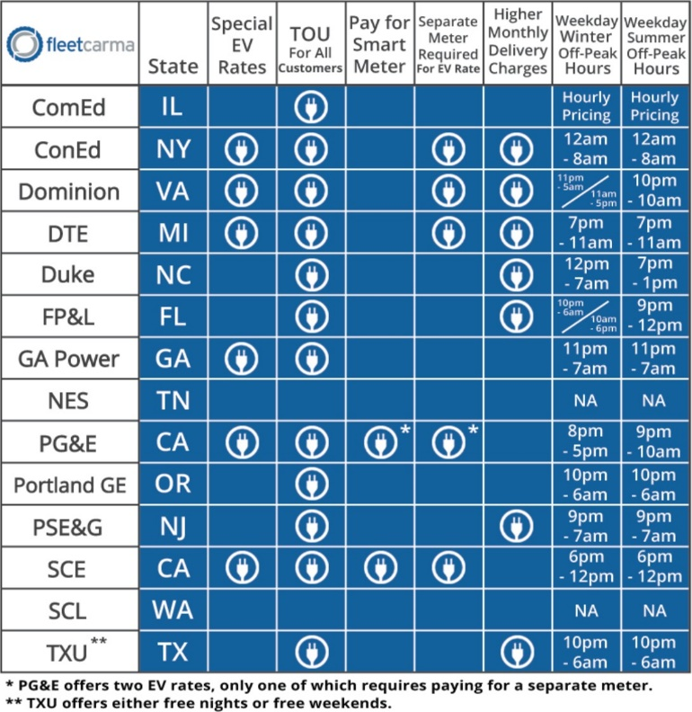

Figure 22 TOU strategies from different utility companies (Fleetcarma)

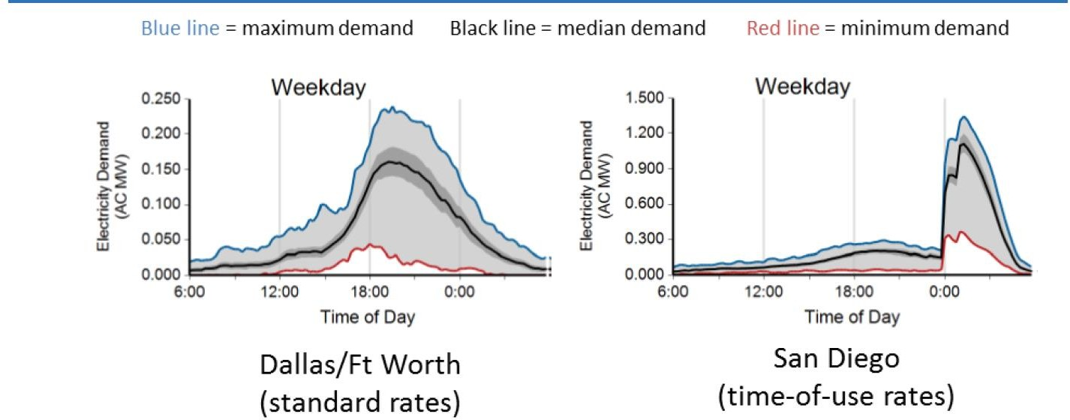

Figure 23 EV Charging Load in Dallas/Ft Worth and San Diego area, EV Project [44444]

The figure shows how the electricity demands change with and without TOU program. The right graphic shows the EV charging load with off-peak benefit in San Diego. If Tacoma Power could make similar time-of-use rates like San Diego, the flatten electricity demand becomes possible.

Based on the assumptions (Nissan Leaf 6.6 kW, battery size 30 kWh, Level 2 charger, 4.5 hours, every EV charge once in a day with 2,000 EVs), impact assessment on electricity consumption profile in Tacoma could be estimated. There are two scenarios in this impact scenarios: 1) uniformly distributed charging through a day and 2) only charging at 0 to 6 pm a day.

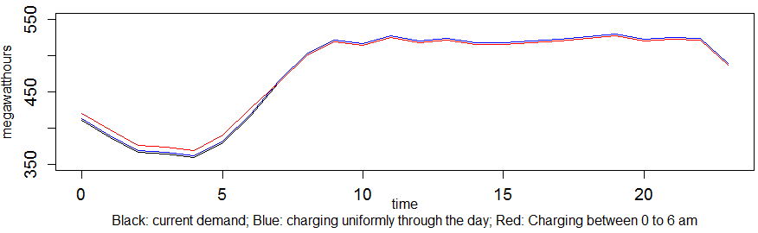

Figure 24 Electricity consumption profile estimation by adding 2,000 EVs in Tacoma

Considering the amount of electricity consumption in the city, by adding 2,000 EV to the grid seems not as significant as expected. On the other hand, with the rapid trend of increasing EVs in the city, by adding 20,000 EVs to the grid in the city may influence the city’s energy consumption profile. Below is the estimation of the electricity consumption profile with adding 20,000 EV to the city gird.

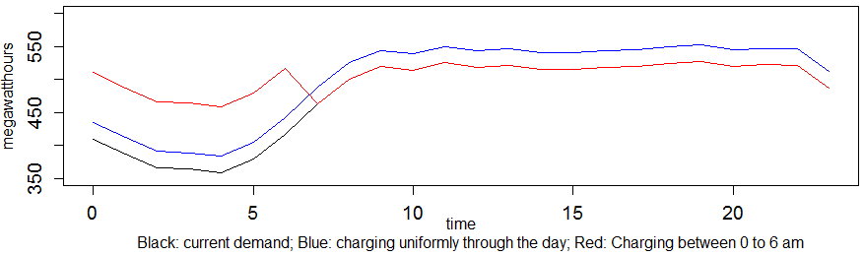

Figure 25 Electricity consumption profile estimation by adding 20,000 EVs in Tacoma

Smart Charger

For city of Tacoma, another problem related to the EV adoption is the burden on charging infrastructure and electric utility grids. A major concern is that local distribution grid may not be sufficient when electric cars are widely accepted, especially when large amount of EVs charge at the same time so that local distribution grids are not able to accommodate the power demand in peak hours[45]. Together with power demand from other sources in people’s daily life, power demand modification and management might be necessary. For EVs, power pricing from the utilities and promotion of smart chargers would be possible options. For the latter, some EV companies such as Nissan Leaf and Chevy Volt have already added the function of delayed/ scheduled charging directly into their production, which could be a strong competitive alternative for smart chargers and a future direction for EV products[46].

Utilities could possibly manage customers’ demand using price so that more people could be attracted to purchase smart chargers. Offering EV owners discounted rates for charging their vehicles during the night might decrease the power demand in peak hours during the day. Some possible options for electric tariff types are shown in the following table and figure. A few researches have been taken to explore the relationship between price cut and demand shift. Results show that day-ahead notification in advance and significant pricing level, e.g., 400% to 600% times greater during peak hours than off-peak hours, could lead to a price elasticity of about -0.10 to -0.16 [47][48]. More specifically, according to Wolka’s (2010) research in D.C., using CPP electric tariff type and a six-times-greater price in peak hour, power demand decreases by 9.7%.

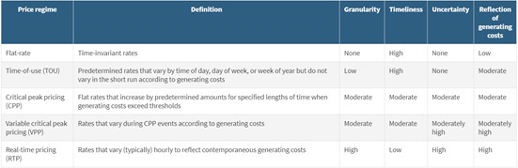

Figure 26 Electric tariff types in the US[49]

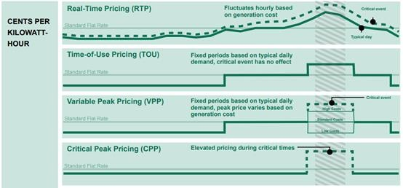

Figure 27 Electric tariff types / pricing options represented[50]

Additional approach[51]

An alternative approach, if the City of Tacoma desires to rapidly increase the number of chargers instead of waiting for incentives to kick in, is to utilize Parks and Schools near MUDs. The residents of the MUD would simply park and charge their vehicle overnight and move it in the morning while these chargers are used by the public or teachers during the day. These locations would be able to serve two groups that may not be able to afford their own charging plugs at their home, but with a dependable charger close by, would be in a better position to make the switch to EV. Summer, while schools are out, is also an opportunity to advertise these locations to the general public, further increasing awareness of charging options and reducing battery anxiety.

A foreseen point of conflict between the MUD residents charging overnight and the teachers charging during the day, is the morning hours where teachers may be arriving at school while the MUD EV owners are still plugged in. A way to minimize this conflict is to have clear signage at the charger and clear communication about the desired use at the time of installation via fliers and announcements on any apps that are used to operate the chargers. Chargers at parks would not have this problem as much, depending on the popularity of the park, because parks do not tend to have a strong draw in the morning.

Elementary and middle schools may be a better option than high schools because they generally start later and have less after school activities, meaning that there would be more time where the parking lot is not in use by the school. Elementary and Middle schools also tend to have smaller lots because students cannot drive yet, which makes communicating with the teachers and the MUD EV owners easier. There are also a larger number of elementary and middle schools in more residential areas, which makes them more accessible by neighboring MUD residents.

One example of a school that is near multiple MUD buildings is the Tacoma Waldorf School, with 4 MUD buildings within a 0.4 mile walk. This school has about 36 parking spaces, so starting with 5%, or 2 smart plugs would be suggested. This would cost about $5,000, assuming that the voltage needed is readily available. An example of a park in Tacoma with neighboring MUD buildings is the Oakland Madrona Park. The park has 5 MUD buildings within a 0.4 mile walk. The park currently has about 20 paved parking spaces, but there may be space to pave more. Installing 2 smart plugs would cost about $5,000 assuming that the voltage needed is readily available.

A more complicated location would be a Park and Ride. Commuters would have the opportunity to park and charge their EV before jumping on the bus, while neighboring MUD EV owners can park and charge during the night. A point of conflict between these two groups again is the morning hours where commuters may be arriving early, while EVs from the MUD EV owners are still plugged in. Again, effective communication would be required to minimize this conflict. Not only would these locations be convenient for nearby MUD EV owners, they would also be utilized by commuters who would now feel more comfortable switching to EV to complete the last few miles from the bus to home. One example is the Narrows Park and Ride that is joined with War Memorial Park, and within 0.3 walking miles of 4 MUD buildings. The Park and Ride is owned by Pierce County and has about 185 parking spaces, so 5%, or 10 plugs would be recommended. Installing 10 plugs, 5 sets of 2 smart chargers, would cost about $25,000. Placing the chargers for the stalls along the Scott Pierson Trail would be convenient space-wise, but also more visible to passersby, therefore promoting the idea that owning an EV is convenient.

While tackling these public places is a way to quickly improve the situation in some selected spots in Tacoma, it would not be sustainable to apply this approach alone as it would not sufficiently cover all MUD residents. This makes it necessary to make use of policies as created in this report in addition to this quick starter.

**Conclusion**

As stated previously, the goal of these actions is to encourage the use of Electric Vehicles in Tacoma. As expected, these chargers may not be fully utilized immediately after installation as EV ownership continues to grow. The demand should rise to meet the supply, and from what can be seen in the history of EV recently, it will.

In the scope of this paper, a couple of challenges were discussed regarding the installation of EVSE at single family households and MUDs. Among others, these were the large variance in social characteristics, the large variance in EV readiness in between different buildings and the large variance in cost to install chargers. Furthermore, the attractiveness for an installation is significantly different between single family households or condo and apartment complexes. This was confirmed through showing how the DPP differs in reaching the break-even of the investment for different ownership structures. Taking these findings into account and the existing policy overviews, it was decided to offer the City of Tacoma a range of options to either optimize their policies for efficiency or for equity and peak demand strategies, as it was not entirely clear what should be pursued at a higher priority. Based on a fairness model, the effects of the policy optimization were illustrated, and corresponding policy proposals were developed including a final cost estimate for each policy. Furthermore, it is recommended to focus on owner occupied households to maximize the efficiency of the policy in an initial stage of EV charging deployment while consider the equity in a long run. Lastly, an additional option that could deliver quick wins through making use of charging at public places was provided, which could be pursued in addition to the policy proposals.

Seeing as there is a significant number of residents in Tacoma that live in MUDs, these policy proposals will increase the attractiveness of owning and operating an EV for residents of MUDs and furthermore motivate them to make the switch to a more sustainable mode of mobility. This will deliver significant added value to the emissions reduction targets of the City of Tacoma. Additionally, since MUD buildings are dense, an installation can get the attention of other residents and thus cause more people to consider moving towards EVs. Together with the results of the investigations on single family charging, this should deliver a valuable contribution to the achievement of Tacoma’s electric mobility targets for 2020.

A final recommendation that aims at receiving more accurate cost estimates, is to pursue a thorough inventory analysis that investigates the real distributions of EV readiness, income distribution, ownership structure and expected desire to own electric vehicles within the residents, since this analysis had to make many assumptions to estimate the expected benefits, costs and dynamics. This could be achieved through surveys, sampling or enhanced census data. Further analysis should assess, whether the trade-off in cost for this inventory analysis is worth the gain in data accuracy.

1. “2017-2018 Projects.” UW News, www.washington.edu/livable-city-year/2017-2018-projects/.
2. ACS 2016, https://www.psrc.org/sites/default/files/acsprof16_pl_tacoma.pdf
3. PSRC residential building permits, https://www.psrc.org/residential-building-permits
4. Plugshare, https://www.plugshare.com
5. Smart et al., Battery Electric Vehicle Driving and Charging Behavior Observed Early in The EV Project, SAE International Journal of Alternative Powertrains, Vol. 1, No. 1 (June 2012), pp. 27-33
6. [6]PSRC household travel survey 2016, https://www.psrc.org/household-travel-survey-program
7. https://www.sce.com/wps/portal/home/business/electric-cars/MUD/
8. https://www.sce.com/wps/portal/home/residential/electric-cars/charging-and-installation/
9. Sears, J., Roberts, D., & Glitman, K. (2014, July). A comparison of electric vehicle Level 1 and Level 2 charging efficiency. In Technologies for Sustainability (SusTech), 2014 IEEE Conference on (pp. 255-258). IEEE.
10. Forward, E., Glitman, K., & Roberts, D. (March 2013). An Assessment of Level 1 and Level 2 Electric Vehicle Charging Efficiency. Vermont Energy Investment Corporation, Transportation Efficiency Group.
11. Sears, J., Roberts, D., & Glitman, K. (2014, July). A comparison of electric vehicle Level 1 and Level 2 charging efficiency. In Technologies for Sustainability (SusTech), 2014 IEEE Conference on (pp. 255-258). IEEE.
12. https://www.energy.gov/eere/electricvehicles/charging-home
13. Tesla Inc., https://www.tesla.com/sites/default/files/downloads/en_HK/multi-unit-property-presentation_en_HK.pdf
14. “Home Charging Station Store.” ChargeLab, www.chargelab.co/store.
15. Take Credit for Going Green. https://www.chargepoint.com/products/home-station-incentives/
16. Personal Use EV Charger Rebates | Anaheim, CA - Official Website. https://www.anaheim.net/593/Personal-EV-Charger-Rebate
17. WAC 51-50, Chapter 4, Section 427.
18. https://dor.wa.gov/content/electric-vehicle-batteries-and-electric-vehicle-infrastructure-charging-stations-salesuse-tax-exemption-leasehold-tax-exemption
19. https://www.energy.gov/eere/electricvehicles/electric-vehicles-tax-credits-and-other-incentives
20. http://nwnewsnetwork.org/post/electric-car-tax-incentive-soon-expire-washington-just-starting-oregon
21. http://cms.cityoftacoma.org/Planning/Zoning_booklet_FINAL_2015update.pdf
22. https://factfinder.census.gov/faces/tableservices/jsf/pages/productview.xhtml?src=CF
23. https://www.energy.gov/eere/electricvehicles/charging-home
24. http://cms.cityoftacoma.org/cedd/housing/consolidated_plan/Tacoma-Lakewood_CONSOLIDATED_PLAN_DRAFT_3-24-15.pdf
25. https://codes.findlaw.com/co/title-38-property-real-and-personal/co-rev-st-sect-38-12-601.html
26. https://www.oregonlegislature.gov/bills_laws/ors/ors091.html
27. https://pluginamerica.org/wp-content/uploads/2017/04/Oregon_Electric_Vehicle_Factsheet_May_2017.pdf
28. https://www.colorado.gov/governor/sites/default/files/colorado_electric_vehicle_plan_-_january_2018.pdf
29. https://www.greencarreports.com/news/1095929_california-washingon-lead-all-other-states-in-electric-car-ownership-rates
30. Traut et al., US residential charging potential for electric vehicles, https://www.cmu.edu/me/ddl/publications/2013-TRD-Traut-etal-Residential-EV-Charging.pdf
31. “Electrical Work & Repair Costs.” HomeAdvisor, www.homeadvisor.com/cost/electrical/#panel.
32. “Commercial & Workplace EV Charging Stations.” AeroVironment, Inc. Online Store, 22 May 2018, store.evsolutions.com/commercial--workplace-ev-charging-stations-c35.aspx.
33. Fee Estimator - Tacoma Permits, City of Tacoma, tacomapermits.org/pds-resource-library/fee-estimator.
34. Federal Highway Administration Census Bureau, 2017, https://www.fhwa.dot.gov/policyinformation/statistics.cfm
35. NHTSA, CAFE, https://www.nhtsa.gov/laws-regulations/corporate-average-fuel-economy
36. US Energy information administration, https://www.eia.gov/
37. Electricity Local, https://www.electricitylocal.com/states/washington/tacoma/
38. McCoy et al., Using Fairness Models to Improve Equity in Health Delivery Fleet Management, https://doi.org/10.1111/poms.12101
39. Tal et al., Exploring Household and Vehicle Fleet Characteristics of New Plug-In Vehicle Owners, https://merritt.cdlib.org/d/ark:%252F13030%252Fm56692z3/1/producer%252F2013-UCD-ITS-RR-13-02.pdf
40. http://cpace.com
41. https://www.zillow.com/tacoma-wa/home-values/
42. https://smartasset.com/taxes/washington-property-tax-calculator#OpQg67y8b0
43. McDonald, Darrin. “Electric Utility Led EV Incentive Programs Help Grid Stability, Reduce Emissions, Manage Costs, and Provide Greater Efficiency.” FleetCarma, FleetCarma, 20 Sept. 2017.
44. M.J. Bradley & Associates (september 2017). Plug-in Electric Vehicle Cost-Benefit Analysis:Illinois. Electric Vehicle Cost-Benefit Analysis.
45. https://www.fleetcarma.com/impact-growing-electric-vehicle-adoption-electric-utility-grids/
46. 2018 LEAF Owner’s Manual. https://owners.nissanusa.com/content/techpub/ManualsAndGuides/LEAF/2018/2018-LEAF-owner-manual.pdf
47. Bollinger B, Hartmann WR. 2016. Welfare effects of home automation technology with dynamic pricing. Work. Pap., Fuqua Sch. Bus., Duke Univ., Durham, NC. http://www.bryanbollinger.com/index_files/HomeAutomation.pdf
48. Jessoe K, Rapson D. 2014. Knowledge is (less) power: experimental evidence from residential energy use. Am. Econ. Rev. 104(4): 1417–38
49. https://www.annualreviews.org/doi/10.1146/annurev-resource-100516-053437
50. https://www.edf.org/sites/default/files/time-variant_pricing_fact_sheet_-_april_2015.pdf
51. Map of Tacoma Schools, Parks, and MUD Buildings. https://drive.google.com/open?id=1ncuiY2wF_9CUSs1wWSGo97XKPkmtF4UK&usp=sharing